From: http://thesaker.is/russia-china-and-the-european-peninsula/
Aggregated onto: https://www.zerohedge.com/geopolitical/russia-china-european-peninsula

Russia, China, and the European Peninsula
10970 ViewsNovember 01, 2019 69 Comments
By Godfree Roberts for The Saker Blog
Eurasia has most of the world’s wealth, resources, and population — yet there is very low economic connectivity. A Sino-Russian partnership can collectively create a gravitational pull that allows them to capture the geoeconomic levers of power by creating an alternative to the Western-centric model. This entails developing new global value chains that captures the high-value activities in strategic industries and energy markets, developing new transportation corridors through Eurasia and the Arctic, and constructing new financial instruments such as development banks, trade/reserve currencies, technical standards, and trade regimes. Russia’s comparative advantage derives from its geographical expanse by developing
- an East-West corridor connecting Northeast Asia with Europe, and
- a North-South Corridor that links India, Iran and Russia.
Moscow sees itself as a stabilising factor in Eurasia by bringing together the entire continent with economic connectivity to ensure that it becomes multipolar and no one state or region can dominate. The EU stands to lose much from Russia’s Greater Eurasia ambitions. Russia’s original Greater Europe project, which they [the] EU rejected, would have endowed the EU with a powerful ally to collectively project influence deep into the Eurasian continent. In contrast, Russia’s new Greater Eurasia initiative will marginalise the EU’s role across Eurasia as socio-economic and political decisions will be made by BRICS, the Eurasian Economic Union, the Shanghai Cooperation Organisation, and the Belt and Road Initiative. The EU is faced with a dilemma as it has strong economic incentives to cooperate with the development taking place in Greater Eurasia, yet this would contribute to the shift away from the Western-centric geoeconomic infrastructure.
Glenn Diesen. The Global Resurgence of Economic Nationalism.
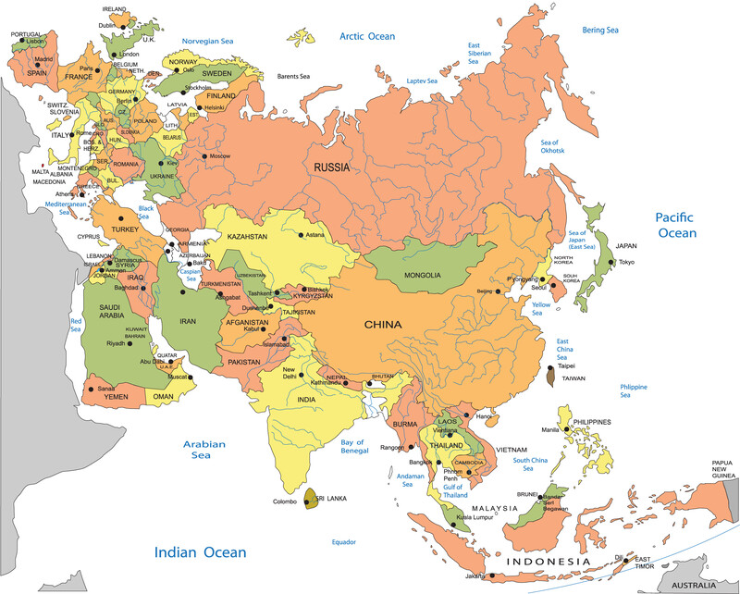

Halford Mackinder[1] said we don’t think of Asia and Europe as a single continent because sailors couldn’t voyage around it.

[1] The Geographical Pivot of History, Royal Geographical Society, 1904, Mackinder extended the scope of geopolitical analysis to the entire globe.

Today the Northeast Passage, NEP, along Russia’s northern coast, links the Pacific and Atlantic coasts while a network of pipelines and air, rail, road and fiber routes are knitting Mackinder’s World Island into ‘Eurasia’ despite Kissinger’s [<- link] warning, “Domination by a single power of either of Eurasia’s two principal spheres–Europe or Asia–remains a good definition of strategic danger for America. For such a grouping would have the capacity to outstrip America economically and, in the end, militarily.”
As the West pursues an increasingly dystopian future, Russia and China are knitting Mackinder’s World Island into a vast, increasingly prosperous community. Their vision is so seductive, their alliance so strong, their weapons so advanced and their pockets so deep that their momentum is almost unstoppable. Russia’s leaders–Putin, Lavrov, Nabiullina, Siluanov and Shoygu–is the best in the country’s history and, as President Trump [<- link]observed, China’s matches it, “People say you don’t like China. No, I love them. But their leaders are much smarter than our leaders. It’s like taking the New England Patriots and Tom Brady and having them play your high school football team.” President Xi has visited Moscow more than any other capital city and as of August 2019, he and his Russian counterpart Vladimir Putin had met thirty times and Xi gave Putin China’s first-ever friendship medal, calling him “my best, most intimate friend.”
Here are Eurasia’s current trade, security, and cooperation blocs. After the June, 2019 Conference on Interaction and Confidence-Building Measures in Asia (CICA) in Dushanbe, Tajikistan, Putin stressed that all of them should be integrated.
***
Colonial nations lost their political and economic freedom because imperial centers of capital needed to control resources crucial for their survival, wealth, and power[2]. This is the real meaning of the terms ‘national security’ and ‘national interest.’ Powerful nations’ ‘national security’ is the control of an economic empire of subject states and the strategies through which this is carried out are ‘national security secrets.’ They practice the antithesis of what they preach. Their trumpeting of peace, freedom, justice, rights, democracy, and majority rule disguises those strategies for controlling other people and their resources be kept secret. The most pernicious is that multi-party democracy and a free press and must precede successful development. In fact, such a combination ends all hope of development. No nation has ever developed under multiparty democracy nor, as Lee Kwan Yew[3] observed, with a free press,

[2] Economic Democracy: The Political Struggle of the 21st Century. By J. W. Smith
[3] A Third World Perspective on the Press. RH Lee Kwan Yew, Prime Minister of Singapore. C-SPAN, APRIL 14, 1988

The Philippines press enjoys all the freedoms of the US system but fails the people: a wildly partisan press helped Philippines politicians flood the marketplace of ideas with junk and confuse and befuddle the people so that they could not see what their vital interests were in a developing country. And, because vital issues like economic growth and equitable distribution were seldom discussed, they were never tackled and the democratic system malfunctioned. Look at Taiwan and South Korea: their free press runs rampant and corruption runs riot. The critic itself is corrupt yet the theory is, if you have a free press, corruption disappears. Now I’m telling you, that’s not true. Freedom of the press, freedom of news critics, must be subordinated to the overriding needs of the integrity of Singapore and to the primacy of purpose of an elected government.
Russia and China offer an alternative to the imperialist model: security without coercion, aid without conditions and, instead of the WTO’s agreements that prevent sustainable development, trade and development pacts to promote it.
The blocs in play are
- the European Union;
- The Eurasian Economic Union;
- The Shanghai Cooperative Organization;
- The Association of Southeast Asian Nations;
- The Regional Comprehensive Economic Partnership;
- The Belt and Road Initiative.
Note that all but one of these are Russo-Chinese. Let’s look at them in more detail.

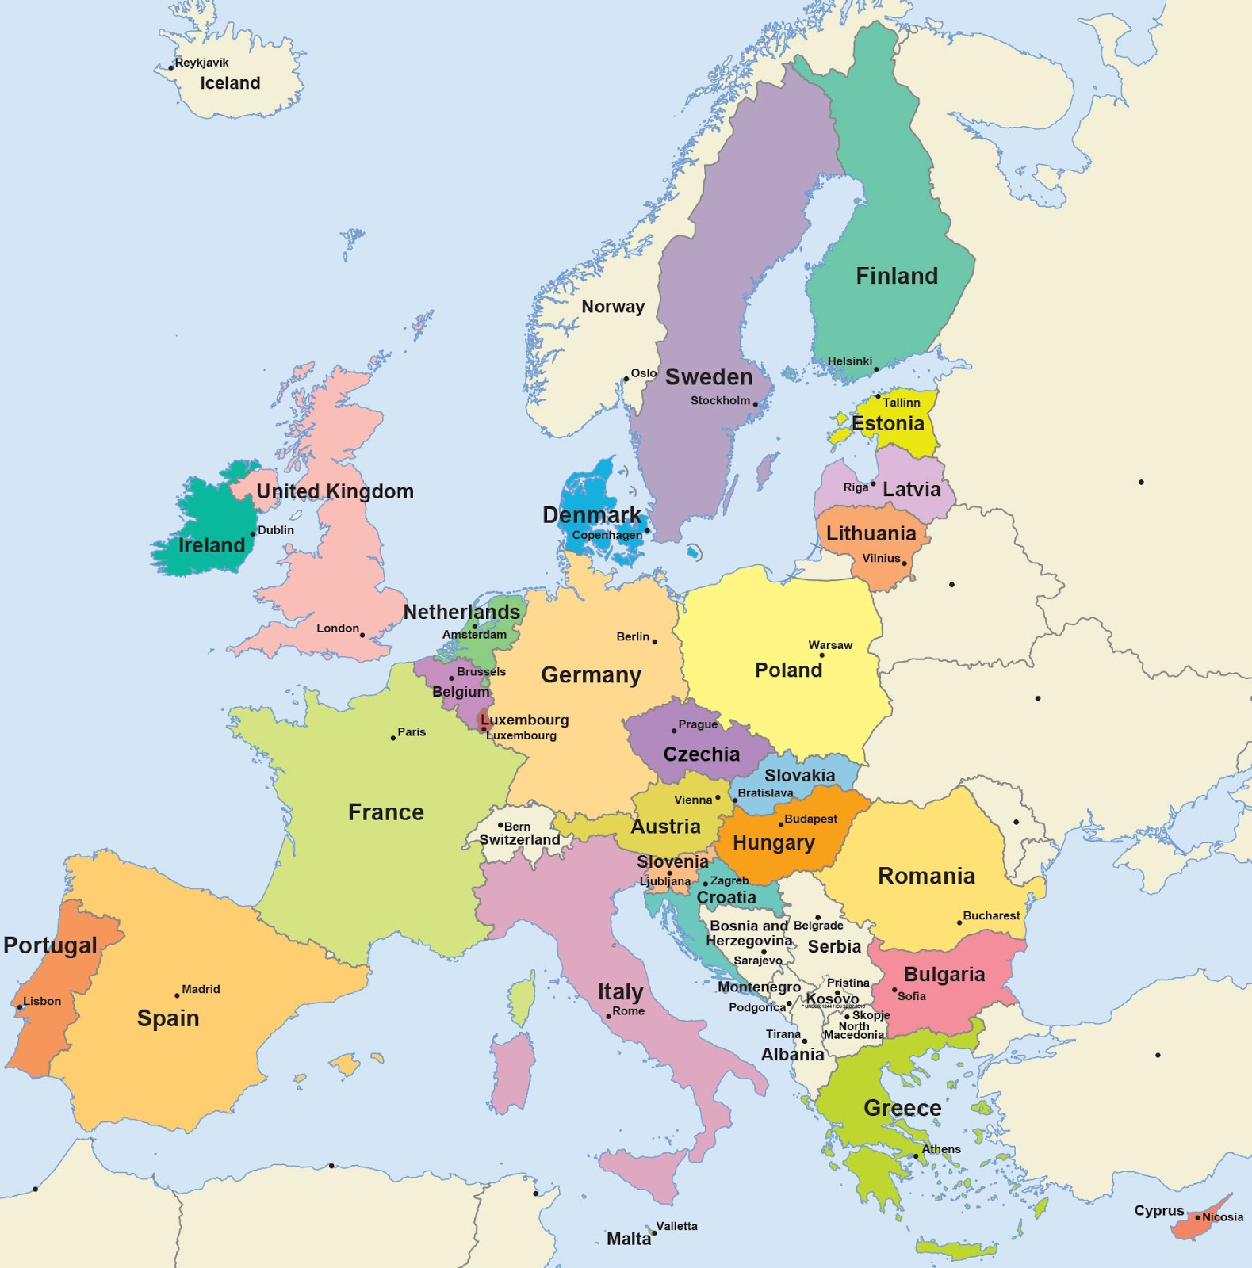
The European Union, occupying Eurasia’s Western peninsula, is tired of the status quo. President Macron said, “We are undoubtedly experiencing the end of Western hegemony over the world…Things change, and they have been deeply shaken by the mistakes of Westerners in certain crises, by the choices that have been made by Americans for several years...And then there is the emergence of new powers whose impact we have probably underestimated for a long time. China is at the forefront, but also the Russian strategy, which has, it must be said, been pursued more successfully in recent years…They think about our planet with a true logic, a true philosophy, an imagination that we’ve lost a little bit.” [Saker’s Translation] [<- link]. Mark Carney[<- link], Governor of the Bank of England added, “The world’s reliance on the US dollar won’t hold’ and needs to be replaced by a new international monetary and financial system… It is worth considering how an SHC [synthetic hegemonic currency] in the IMF could support better global outcomes.”6 Germany is completing Nord Stream II and installing Huawei despite US threats, and Hungary, Greece, and Italy are turning east. One more downturn in the US economy (where manufacturing is already in recession[<- link]) and the rest of the EU will follow. Turkey’s President Erdogan[4], on NATO’s Eastern flank, said he bought Russia’s S-400 so Turkey could safely withdraw from NATO: his country is already a dialog partner in the world’s largest security association, the SCO.

[4] President Erdogan said he bought Russian S-400s so he could withdraw from NATO and join the SCOand Tajikistan, with Moldova in consideration) is devoted to free movement of goods, services, capital and labor and coordinated, coherent and common policies in all key economic sectors. In the past two years Russia’s EAEU trade has increased dramatically: with Armenia (30%), Belarus (10%) Kazakhstan (21%), and Kyrgyzstan (17%). China is negotiating product tariffs on its existing FTA agreement and, in the past two years its EAEU trade has risen rapidly, too: Armenia (29%), Belarus (35%), Kazakhstan (48%) and Kyrgyzstan (31%). Minsk and Moscow are seeking to unify their customs and energy policies by 2021 and the union’s state tax code is expected to be adopted by the Spring of 2021, and a single tax code, civil code, and list of foreign trade rules, in addition to unified oil, gas and electricity market regulators by 2022. In soft power terms, Russian remains the lingua franca in Mongolia, Central Asia and the Caucasus.

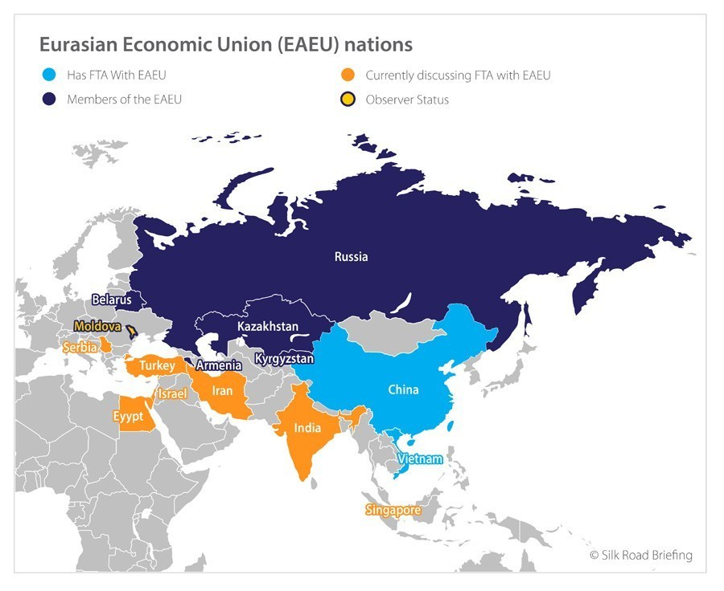
The Shanghai Cooperative Organization, SCO. (Russia, Kazakhstan, Kyrgyzstan, Tajikistan, Uzbekistan, India, China, and Pakistan; with Afghanistan, Iran, Mongolia and Belarus as observers and Armenia, Azerbaijan, Cambodia, Nepal, Sri Lanka and Turkey as dialog partners).
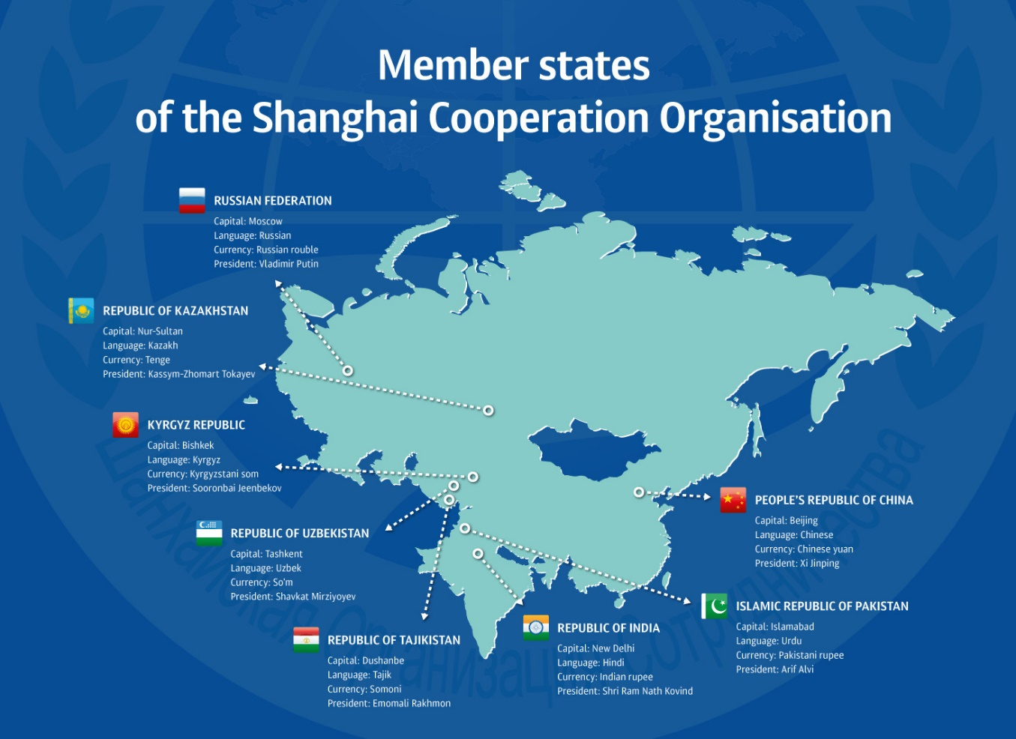
The SCO is the world’s largest security organization and counts four nuclear powers among its members. Its objectives are to (i) strengthen relations among member states; (ii) promote cooperation in political affairs, economics and trade, scientific-technical, cultural, and educational spheres and in energy, transportation, tourism, and environmental protection; (iv) safeguard regional peace, security, and stability; and (v) create a democratic, equitable international political and economic order. SCO members have completed an intergovernmental agreement facilitating international road transport and are finalizing one on rail transport. The Bishkek Declaration, adopted by SCO members, emphasizes the security guarantees of the Central Asian Nuclear-Weapons-Free Zone Treaty, the ‘unacceptability of attempts to ensure one country’s security at the expense of other countries’ security,’ and condemns ‘the unilateral and unlimited buildup of missile defense systems by certain countries or groups of states.’ Iranian President Hassan Rouhani, speaking to Presidents Putin, Xi, Modi and Imran Khan, blasted the US as ‘a serious risk to stability in the region and the world” and offered preferential treatment for all fellow SCO nations, companies, and entrepreneurs to invest in Iran’s market. Xi responded that Beijing will keep developing ties with Tehran ‘no matter how the situation changes.’
ASEAN. Established in 1967, the Association of Southeast Asian Nations–Brunei Darussalam, Cambodia, Indonesia, Laos, Malaysia, Myanmar, Philippines, Singapore, Thailand, and Vietnam–agreed to accelerate their region’s economic growth, social progress and cultural development through joint endeavors in the spirit of equality and partnership in order to strengthen the foundation for a prosperous and peaceful community and to promote regional peace and stability through abiding respect for justice and the rule of law in the relationship among countries in the region and adherence to the principles of the United Nations Charter. Russia and China are strategic ASEAN partners but, though ASEAN had a much longer dialog partnerships with the Western countries like America and the EU, none of them proposed a free trade agreement for ASEAN. China did so in 1988 and then concluded the ASEAN-China FTA in record time with the result that total trade between ASEAN and China, $8 billion in 1991, grew to $600 billion in 2018 with a goal of $1 trillion by 2024.
The Regional Comprehensive Economic Partnership[5], (Brunei, Cambodia, Indonesia, Laos, Malaysia, Myanmar, the Philippines, Singapore, Thailand, Vietnam, China, Japan, India, South Korea, Australia and New Zealand). The world’s largest trade bloc, the RCEP accounts for half the world’s economy and, in contrast to the WTO, is biased in favor of developing nations and excludes investor-state dispute settlement (ISDS)[6] mechanisms that advantage private corporations over states.

[5] According to PwC, RCEP member states GDP, PPP, will be $250 trillion by 2050, with the combined GDPs of China and India making up more than 75% of that. RCEP’s share of the global economy could account for half of the $0.5 quadrillion global GDP by 2050.
[6] ISDS clauses allow foreign investors to sue national governments for any measures that harm their profits. NGOs, corporations over states trade unions, charities and faith groups say they are a threat to human rights, health and the environment.

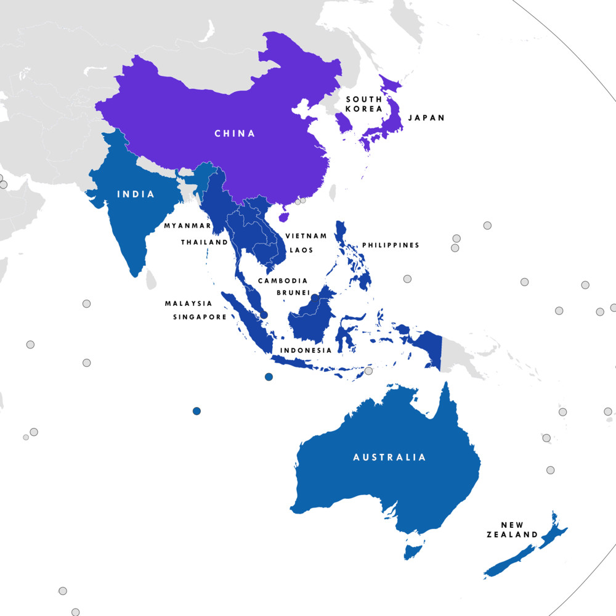
The Belt and Road Initiative. Scheduled to launch on June 1, 2021, the BRI integrates four billion people in one-hundred thirty countries across Eurasia, Africa, Latin America and the South Pacific. BRI focuses on policy coordination, infrastructure connectivity, unimpeded trade, financial integration and people-to-people ties. It is building power plants in Pakistan, train lines in Hungary and ports from Africa to Greece, replacing Western institutions, refashioning the global economic order, forging new ties, creating new markets, deepening economic connections and strengthening diplomatic bonds. Iran is a key BRI node and Tehran sees it as the way to full integration into the Eurasian economic ecosystem. Cargo transiting from all over India via the International North-South Transport Corridor, INSTC, to the Iranian port of Bandar Abbas reduces shipping costs to Europe by forty percent. The INSTC will soon merge with BRI’s global transport network.
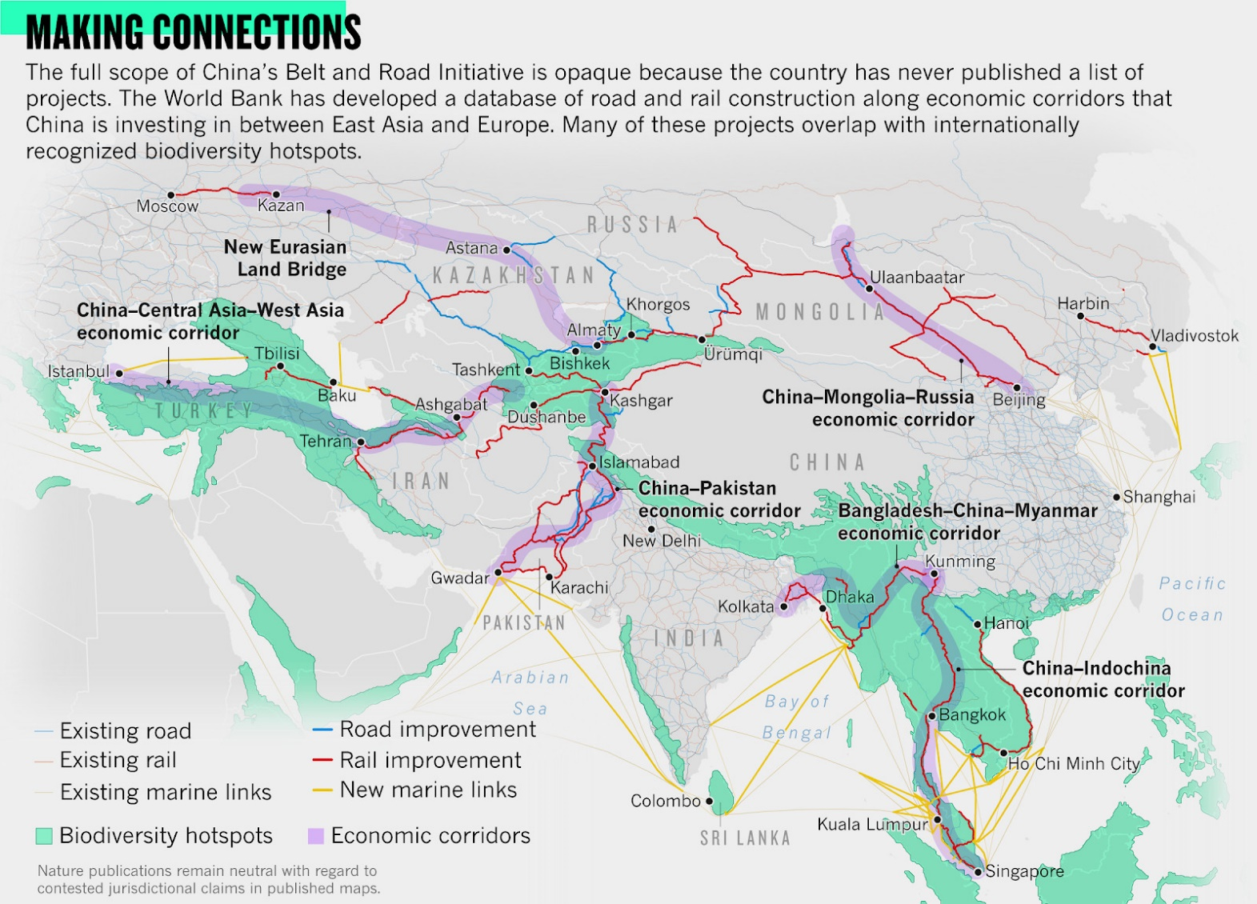
The BRI’s Eurasian Land Bridge exemplifies its cooperative model. Added value production–like assembling component parts from different origins–can be conducted tax free in its border Free Trade Zones, where wages are one-fifth of China’s. This allows for the addition of lower cost labor, depending upon the location, to be factored into the overall production cost rather than being exposed to one salary band in just one country. Goods entering these FTZs are considered to be outside customs borders, so attract no customs duty or VAT, and companies operating within them are exempt from all taxes. The nodes: Huoergousi Export Processing Zone (China-Kazakhstan Border); Khorgos Eastern Gate Special Economic Zone (Kazakhstan); Aktau Special Economic Zone (Kazakhstan); Alat Free Trade Zone (Azerbaijan); Poti Free Industrial Zone (Georgia); Hualing-Kutaisi Free Industrial Zone (Georgia). Turkey’s East Anatolia Free Trade Zone is the most interesting, since Turkey’s Custom Union with the EU admits Turkish origin goods free of tax. Over 6,300 trains made the journey last year, one every ninety minutes. Trans-Eurasia transit time has fallen from three weeks to two, and should be ten days by 2024. Ultimately, Russia aims to connect China’s northern provinces with Eurasia via the
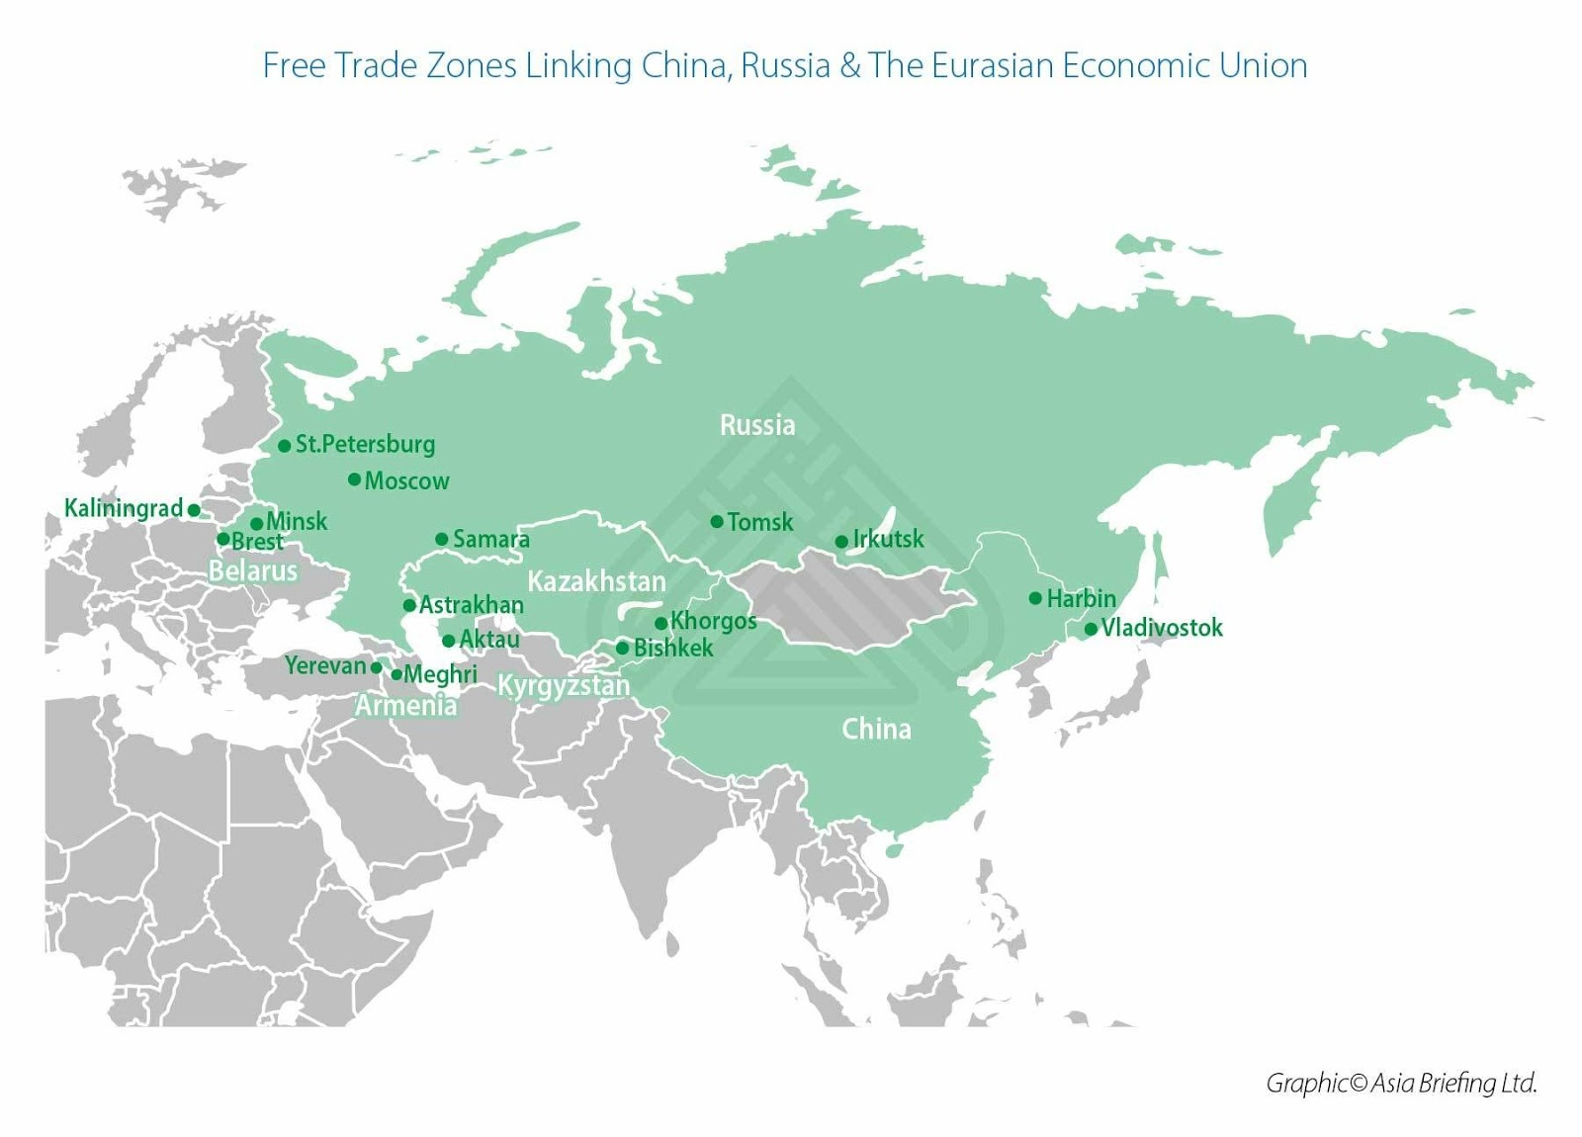
The Trans-Siberian and the Chinese Eastern Railway–with Chita in China and Khabarovsk in Russia, are already totally interconnected. Across the spectrum, Moscow aims at maximizing return on the crown jewels of Russia’s Far East; agriculture, water resources, minerals, lumber, oil and gas. Construction of liquefied natural gas (LNG) plants in Yamal vastly benefits China, Japan and South Korea. The same applies to gateway Vladivostok, Eurasia’s entry point for both South Korea and Japan, as well as Russia’s entry point to Northeast Asia. Kazakhstan shows how Greater Eurasia and BRI are complementary: Astana is a member of both the BRI and the EAEU.
TOOLS OF THE TRADE
The Polar Silk Road sea route is five-thousand miles shorter than the Suez route that runs mostly in Russia’s coastal waters. In 2010 the first cargo ship sailed the entire route without icebreaker assistance and in 2017 the Christophe de Margerie became the first ever ice-breaking LNG carrier to transport LNG from the Yamal peninsula through the Bering Strait and south to Japan and China. Russia’s Sovcomflot and Novatek signed an agreement with China’s Cosco Shipping and the Silk Road Fund to establish a Maritime Arctic Transport joint venture to manage an ice-breaking tanker fleet in the transportation of LNG for current and planned Novatek projects including Yamal LNG, Arctic LNG 2 and others.
Pipelineistan. The IEA calculates that oil will remain the world’s dominant source of energy in 2040, accounting for one-fourth of global energy consumption. Russia accounts for fifteen percent of the world’s energy reserves and the Persian Gulf region for 65%. Russian and Chinese-built pipelines are distributing this energy wealth across the continent resurrecting the South Stream gas pipeline to supply Europe as an extension of TurkStream after the Trump administration also furiously opposed the Nord Stream 2. Russian gas will start flowing to Turkey via TurkStream this year and Russia and Bulgaria have begun work on the Balkan Stream Pipeline to carry gas to the southern EU.
The Global Electric Interconnect. Beijing launched GEIDCO in 2016, an ultra-high voltage grid that will transmit clean energy around the globe continually, following the sun. GEIDCO has seven regional offices, forty global offices, six-hundred regional and national members and has invested $1.6 trillion in eighty generation and transmission projects across Eurasia, Latin America, Africa, Europe and North America.
The Digital Silk Road. The DSR is strengthening internet infrastructure, deepening space cooperation, developing common technology standards, and improving the efficiency of policing systems among Belt and Road countries. It gathers space-based remote sensing data for multiple projects along the BRI and China is promoting BeiDou-2, its global satellite navigation system as an alternative to America’s GPS. Pakistan, Laos, Brunei, and Thailand have already adopted BeiDou. Construction has begun on the Pakistan East Africa Cable Express, connecting Pakistan to Kenya and Djibouti. In 2012, under one percent of Myanmar’s population had broadband access but the country expects to launch 5G broadband service by 2025, leapfrogging even Singapore.
Russia and China’s Electronic Funds Silk Road will Replace the US-dominated SWIFT network.
The Silk Road International Bank AIIB guarantees a trillion dollars annually in long-term, low interest loans for regional infrastructure, poverty reduction, growth and climate change mitigation and allows Eurasia’s four billion savers to mobilize local savings that previously had few safe or creative outlets. Nothing could be more sensible for the new Pipelineistan deal than to have it settled in yuan. Beijing would pay Gazprom in that currency (convertible into rubles); Gazprom would accumulate the yuan; and Russia would then buy myriad made-in-China goods and services in yuan convertible into rubles. The merger of Russia’s Mir payment system and China’s Union Pay appears inevitable because their bilateral trade is growing by an astonishing half a billion dollars a month and Beijing’s fully convertible digital yuan may debut as soon as this year, adding to the fun.
Invulnerability to attack. In the past eighteen months, Russia and China have demonstrated their ability to defend themselves against any attack and, in turn, to destroy every city in the United States inside forty-five minutes. They now operate from a position of strength, particularly in Eurasia.
HEGEMONY AND HUMANITARIAN LEADERSHIP.
According to Chinese philosopher Xunzi, there were three types of leadership: humane authority, hegemony and tyranny.
Humane authority begins by creating a desirable model at home that inspires people abroad. Xunzi[2], proposed that, though hegemons know how to win wars, “The ruler who makes his own state act correctly will attain international primacy.” The domestic determines the international and, since humane authority based on morality rather than power, is superior to hegemony it is more important to win over people than territory. States wishing to exercise humane authority must be the first to respect the norms they advocate and leaders of high ethical reputation and great administrative ability will attract other states. “To be compassionate in great matters and overlook the small makes one fit to become lord of the covenants. Loving friends, being friendly with the great, rewarding your allies and punishing those who oppose you, the lord of the covenants has a definite duty and his moral standing should match it.” Presiding over the meetings of other states grants international recognition of humane authority. Two centuries later, Confucius summarized Xunzi thus, “Moral superiors and inferiors relate to each other like wind and grass: grass must bend when the wind blows over it”.
A warming, moral wind is blowing across Eurasia and the pieces are coming together.

Godfree Roberts has been studying China since 1967 and is preparing a book, How China Works, for publication this year. His online China oeuvre is available here.

[1] Hegemonic Stability Theory: An Empirical Assessment. Michael C. Webb and Stephen D. Krasner. Review of International Studies. Vol. 15, No. 2, Special Issue on the Balance of Power (Apr., 1989), pp. 183-198. Cambridge University Press
[2] Ancient Chinese Thought, Modern Chinese Power. By Yan Xuetong
[3] “Strengthen Party Unity and Carry Forward Party Traditions” (1956) China’s economy overtook America’s fifty-eight years later.
[4] Build a Harmonious World of Lasting Peace and Common Prosperity. Speech by Hu Jintao at the UN Summit, New York, September 15, 2005
[5] Wang Yi, ‘Exploring the Path of Major-Country Diplomacy with Chinese Characteristics’, Foreign Affairs Journal, No. 10 (2013), p. 14.
[6] The closest look yet at Chinese economic engagement in Africa, By Kartik Jayaram, Omid Kassiri, and Irene Yuan Sun. June 2017. McKinsey.
[7] All Roads Lead to China, by Ehsan Masood. Nature, 2 May 2019. Vol 569
[8] China launches $11 billion fund for Central, Eastern Europe. Reuters, November 6, 2016
[9] Behind China’s $1 Trillion Plan to Shake Up the Economic Order.By Jane Perlez and Yufan Huang. New York Times, May

Comments

69 COMMENTS
- 
Ted Heath on November 01, 2019 · at 6:33 pm EST/EDT
If you read McKinder’s paper that was read to the Royal Geographic Society, you will find that he suggested the fulcrum point of the world that is approximately delineated by the triangle Moscow, Beijing and Tehran, is protected by all rivers NOT draining in to any ocean other than the Artic. Most drain in to inland seas and lakes.
This means that they are safe from invasion from naval powers like the USA and the once dominant fleets of Britain, France and Germany. It is not just the geographic location, resources or political systems these lands do, or do not, employ. It is the sanctity of the lands occupied by States and nations protected from conventional military invasion.
This is the result of no major war involving all these nations, that few, if any writers mention. The ultimate war monger aggressor the USA does not have free health care, which both Russia and China have. There is no high speed rail in the USA, while China has more high speed rail than the USA has rail track of any sort. China has 5G in 100 cities. The USA does not even have 5G technology.
Clearly being a war monger serves no one but the rich.

COMMENTS
I do wish people who use McKinder use him correctly, because he does not say what is often claimed, as in this article.
Reply
ВЕЛИКИ ВУУ on November 01, 2019 · at 7:40 pm EST/EDT
Lucky for them that we don’t live in Seapole. Albeit that would be multipolarity on steroids
Reply
Larchmonter445 on November 01, 2019 · at 8:24 pm EST/EDT
The US doesn’t have 5G because the Chinese stole it from them. Not a chance they’ll give it back either, so the US has to invent it all over again. Ha!
Reply
vot tak on November 01, 2019 · at 8:33 pm EST/EDT
L445
“The US doesn’t have 5G because the Chinese stole it from them. Not a chance they’ll give it back either, so the US has to invent it all over again. Ha!”
Maybe they could lease it… ;-D
Reply
Monte George Jr. on November 02, 2019 · at 12:24 am EST/EDT
Or maybe we are better off without 5G and it’s inevitable corollaries: widespread health impacts in humans and other creatures and the proposed all-pervasive “internet of things”. Perhaps we should put aside our envy and count our blessings.
Reply
Col...'the farmer from NZ' on November 02, 2019 · at 8:52 pm EST/EDT
LM445
If the US doesn’t have 5G then it is at least doing one thing right…for the life of me, I can’t think of much else though LOL!
Col
Reply
Larchmonter445 on November 01, 2019 · at 8:27 pm EST/EDT
“It is the sanctity of the lands occupied by States and nations protected from conventional military invasion.”
Both Russia and China have suffered centuries of invasions. So I don’t get your point.
Reply
Col...'the farmer from NZ' on November 02, 2019 · at 9:27 pm EST/EDT
Ted
Afraid you lost me here…if said “triangle” had rivers draining into “oceans other than the Arctic” then these Western nations could/would use them to invade effectively.
Napolean had a go, so too did Hitler and they didn’t do that well.
In this day and age with modern warfare capabilities would these rivers make a jot of difference?
Roberts has compiled an epic compilation of events that amount to a monumental paradigm shift in global economic and military domination. Surely this should be welcomed by all but the most bloodthirsty die-heart Neocons…and this is your critique?
Personally, I will file this link as a permanent reference. It is far and away the best and most comprehensive analysis of a multitude of positive initiatives I have seen.
Cheers
Col
Reply
Larchmonter445 on November 01, 2019 · at 6:34 pm EST/EDT
A great primer for those who only know pieces of the huge puzzle of Eurasian Integration and BRI.
My only complaint is the maps that show Crimea remaining as the stolen property of Khrushchev’s USSR. Out of date or politically manipulated maps distort reality. Crimea is Russian Federation turf and current maps should be so constructed. All others should be labelled as pre-2014 or propaganda.
Nonetheless, this is a fine tour of the situation Russia and China are constructing to create a multipolar reality for global trade and peace-making.
Download it and save it as a PDF. It is a good resource packed with the facts.
Reply
Anonymous on November 01, 2019 · at 9:04 pm EST/EDT
https://www.stalkerzone.org/zelensky-and-the-nato-secretary-general-made-a-humiliating-gaffe/
Whilst the tapeworm Stoltenberg continues his fecal outflow in Kiev.
Reply
Mulga Mumblebrain on November 02, 2019 · at 3:41 am EST/EDT
That is an insult to tape-worms.
Reply
Nussiminen on November 02, 2019 · at 4:18 am EST/EDT
Mr. Greenclown insulted by a tape-worm. Must boost the latter’s self-confidence, methinks.
Reply
laodan on November 01, 2019 · at 10:07 pm EST/EDT
The world is confronted today by 2 fundamentals:
1. a shift of the center of gravity of the “governance-world” from the West to East-Asia with Beijing at the core.
2. the ‘great convergence of all the side-effects of Modernity’ that threaten not only Modernity but more importantly the principle of life itself (Western societal atomization + climate change + erosion of top soils + poisoning of – birds – insects by industrial agriculture + plastic nano-particles invading the biology of life + mass extinction + a multitude of other …)
This article addresses the first of these fundamentals and the following sentence sketches the essence of the shift that is taking place nowadays:
” As the West pursues an increasingly dystopian future, Russia and China are knitting Mackinder’s World Island into a vast, increasingly prosperous community. Their vision is so seductive, their alliance so strong, their weapons so advanced and their pockets so deep that their momentum is almost unstoppable. ”
But this presentation is unnecessarily weakened by the absence of the 2nd fundamental which is nevertheless going to impact the world in a more fundamental way than the 1st fundamental. The importance of this 2nd fundamental resides in the fact that it appears going to destabilize the completion of the 1st fundamental. The Chinese leadership is well aware of this reality which it sums up in a one sentence “building a Community of Common Destiny for all Humankind by Sharing an Ecological Civilization”. These are not words to propagandize. The Chinese are walking in the path of their talk by leading the world in sustainable technology investments.
Reply
Mulga Mumblebrain on November 02, 2019 · at 3:43 am EST/EDT
Yes-the only hope of averting the ecological Holocaust is China. The West, under a Trump or an Obamanation, is the greatest impediment to that salvation. It’s the Death Impulse, I’m afraid.
Reply
Mortimer on November 03, 2019 · at 11:15 am EST/EDT
Funny to hear this, I find that Yunan ( Dali, Lijiang ), and all that area to surpass Yosemite in beauty, much of China is roadless.
When there are great parks in China, they’re not exploited like in the USA.
When I hear people talk about ecological holocaust, a person that has never traveled there comes to my mind.
As a lifetime mountain climber, and someone who has sailed and climbed desolate areas, I’m tell you all that China is like wilderness compared to the exploited USA.
The USA always operated on Christian Manifest Destiny, murder all, steal all today, for we go to heaven tomorrow.
…
So all of ASIA people are networked and already daily living in a cashless society, everywhere uses smart cards to telephone credit for small purchases. In the USA people lay on the streets, stoned out of their minds, rolling in their own feces talking about how China is polluted.
Highspeed trains in ASIA rival anything on earth, subway systems that are sparkingly clean, and crime free.
In the US ‘public transportation’ is a death gauntlet, the elite always travel by private auto or plane.
Go to Yosemite today, and its like Coney Island New York amusement park, long after it rotted and all the attractions fell down, and the shops became shooting gallerys ( heroin kind )
It’s a twisted and sick world we live in.
…
Obama was a parrot. Trump is an idiot. Nobody cares what he says, only fools use twitter, or facebook.
The death impulse comes from Trumps owner’s ['Trump's owners' ?] in Israel, whom he is in debt for bailing out his mafia real estate rackets for decades. The ‘death impulse’ is more of Western Suicide.
Great article and right on, I have seen this with my own eyes past 40 years of China building into the 21st century, all the while the USA crumbles as even the bridges aren’t being repaired.
The West just want to Kill&Control ( Greater Israel ), limited population, just a few to be servants; Chinese ( Asian ) in general are family people where children take care of their parents until death. Totally different system West verus East, and its no wonder the West has failed and become a cesspool of human feces.
Reply
Mulga Mumblebrain on November 03, 2019 · at 4:20 pm EST/EDT
Mortimer, I agree completely. In the West, thanks to ‘democracy’ which gives a vote to every imbecile, ignoramus, psychopath, racist, misogynist, homophobe and misanthrope, and neo-liberal capitalism which puts the manipulators of finance in charge of society, you have no ‘society’, as Thatcher declared. You have a boiling mass of competing, hating, money-grubbing factions and atomised individuals who must compete not only with one another, to grab some crumbs off the Bosses’ High Table, but also with even more exploited workers in the poor world. The living world is not just commodified, exploited and devastated, but actively despised as something greater than the egomaniacs of the Right, and which, in any case, their ‘God’ (in reality, particularly given its Judaic roots, nothing but their own egos imposed on existence)told them they could ‘dominate’. Domination, that purest expression of hatred mixed with contempt, is the very dead heart of the West, and always has been. Dominate others, dominate Nature, dominate women, dominate the lesser breeds, dominate the future, by destroying it, dominate Truth, dominate across the Full Spectrum, forever. Is it any wonder that China, which operates according to opposite principles, rooted both in socialism and Chinese history and philosophy, is so fanatically and viscerally hated, and FEARED, by the evil imbeciles of the West.
Reply
Alfred (Cairns) on November 02, 2019 · at 2:44 pm EST/EDT
Please forget about “Climate Change”. The climate has always been cyclical and the temperatures have been unchanged for 18 years. In fact, they are about to gently dip because of an inactive sun.
https://www.armstrongeconomics.com/world-news/climate/climate-change-there-has-been-no-warming-for-the-past-18-years/
As soon as they are forced to recognize that the temperatures are falling, they will start feeding us “Ice Age” BS. That news cycle has been repeated several times over the past 120 years.
Reply
Mulga Mumblebrain on November 02, 2019 · at 5:52 pm EST/EDT
Sorry, Alf. The climate does move through various stages in the Milankovich Cycles that govern glaciations and inter-glacial periods in this climate epoch, but only when there is no additional forcing to the system. At present and for the last 200 years that added forcing is the addition of heat-trapping greenhouse gases to the atmosphere, which have slowly, and rapidly in the last forty years in particular, trapped additional heat in the Earth system, particularly the oceans (150 zettajoules, ie 10 to the 21st power, in those 200 years). That’s why the last July was the hottest ever month in recorded history, why the last five years have been the hottest five ever recorded, and why assertions that they have been unchanged for 18 years are simply incorrect. And, as you observe, when the Sun has been very quiet, relatively speaking. Ice Ages are nowhere in sight, simply because of the greenhouse gas forcing, and consequent positive feedbacks like melting permafrost, albedo flips in the high latitudes and warming seas and soils.
This comment is off-topic – please take it to the MFC. Any further will go to trash. Mod.
Reply
amarynth on November 02, 2019 · at 6:18 pm EST/EDT
Mulga has already been warned and asked to stop being off-topic.
Mulga is off-topic again – making wild assertions that so many of us have asked her to tone down and once, just once, give a proper citation. Just one time. But there is this insistence to change everything to Mulga’s topic.
This is now continuous.
Reminder, the topic is
Russia, China, and the European Peninsula
Reply
Grieved on November 02, 2019 · at 1:18 am EST/EDT
Of the handful of great western educators about China, Godfree Roberts is the one I turn to when I want bullet points. He has data, facts, lists, charts and irrefutable reports – so useful to share with others and let them draw their own conclusions regarding the greatness of China.
This is one of the bigger piece I’ve read from Roberts, and it’s a great piece. He is appearing on my radar more lately, as he compiles the information for his book. I suspect this will become a chapter (and will get the final edit that it deserves). We are very lucky to benefit from his diligent research and his admiration of China.
And Saker, thank you for the reading list you publish that continues to amaze me.
~~
I was reading some of the seminal work of Sun Yat-sen from about a century ago. In his early days, when China’s population was the greatest in the world at 400 million, he dreamed that as China regained its sovereignty, then the vast wealth of its resources, culture, skills, and the sheer productive genius of that huge population, could be used to benefit the entire world.
This struck me as an amazingly generous thought for a revolutionary whose principal aim still remained for his country to throw off the shackles of imperialism. For him to be in awe of his own country’s prodigious nature, and to conceive that this greatness surely could only exist as a free gift to the entire world – who can think such a thought?
This still seems completely astonishing to me, as well as completely wonderful, and beyond admiration. I don’t know for certain, but I have read that Dr. Sun is revered throughout China today across all divisions of political thought as the father of the nation.
And so I wonder how much of that remarkable thought that he had still persists within China, or perhaps was actually born in him from China, and even perhaps is the fuel for all the new roads being born in the world?
Reply
Ulrich von Kafkanien on November 02, 2019 · at 3:18 am EST/EDT
About free press: The world has no experience with free press, because the press has always been controlled by class interests. When the 1. world war erupted, the working class press fell in line betraying the working class. When it comes to quasi free press, the West developed after the French revolution with much more press freedom than today. What we observe in our times, is a press engaged in campaign journalism, furthering agendas. It is simply not true that we need less press freedom to develop, we probably need a press that is free and honest, a real watch dog for the national interest, which is the people’s interest.
Reply
Mulga Mumblebrain on November 02, 2019 · at 3:46 am EST/EDT
True, indeed, but today the Western propaganda system is more perverse, biased, mendacious, dishonest yet arrogant, than I have ever seen. Even Big Brother would be nauseated by the lying, hypocrite, thugs of the Guardian, the ABC, the BBC, the Murdoch cancer, the NYT, WaPo, MSNBC, CNN etc.
Reply
Seldes on November 03, 2019 · at 8:00 pm EST/EDT
Long ago Randolph Hearst & JP-Morgan ( USA owners ) said “Freedom of the press, belongs to those who OWN the press”
Not much has changed since the 1910’s, back then they made war “To Order”, same now. Study Hearst and the Spanish war over Cuba.
People talk about defending the Press, so what they mean now is defending Murdoch at Fox-News.
When the press was invented only the RICH or GOV could afford the press, often in early USA the rich guy would buy a press and open a newspaper, but filling the paper with his opinion, which usually was around his desire/goal/mission, as he owned the town.
What has changed? In my lifetime I have seen Zionist’s BUY all the ALT left&right newspapers in the USA, so today the zionists control left, right, center, bottom and top of all human discussion in the USA.
Now the CIA is in charge, but those who know history know that CIA is OSS, which is UK elite, which melded with Wall Street ( GOldman Sacks), and today we have what we have. A cesspool of humanity fed feces.
But never forget that USA began as a penal colony, and post civil-war reverted to a slave colony for wall, and dTrumps wall is to keep the tax-cows contained.
Reply
Rhys Jaggar on November 02, 2019 · at 7:23 am EST/EDT
A Free Press is always free to press the arguments of their owners.
Press Plurality is not the same as Press Freedom.
Press Plurality requires diverse ownerhip, pointing to non Ltd Co ownership forms existing to prevent consolidation during short-term downturns.
Reply
Ulrich von Kafkanien on November 02, 2019 · at 3:32 am EST/EDT
If we had a free press (free television) the West could not pursue that dystopian future, which is the future the 0,000001 wants for us and the people hate it. How could a free French press avoid an honest coverage of the yellow west’s? The lack of a free press is one of the main reasons for the dystopian development in Europe and the US. We need less than ever reasoning like, give up your remaining freedom and you will develop like China. Our Assange has once and for all proved the state of press freedom in our dystopian West.
Reply
Mulga Mumblebrain on November 02, 2019 · at 3:48 am EST/EDT
It was always there for those with eyes that see, but Chomsky and Herman in ‘Manufacturing Consent’ outlined the propaganda role of the Free Press nearly thirty years ago, and it has grown much worse in the years since.
Reply
Nussiminen on November 02, 2019 · at 4:02 am EST/EDT
Godfree Roberts shows convincingly all that which is totally lost on Western ”progressives”. This morning, I read GR’s piece right after the trash which had arrived by mail yesterday (I am considering terminating my subscription to this periodical) and it made my day. Amusingly, the one thing the ”progressive” publication did get right was the undisputable fact that the contemporary Western Left and ditto Labour movement are in serious trouble, but pointing to the positive examples set by contemporary Russia, China, and their increasing number of allies — most notably in the Third World — is an absolute no-no in this milieu. Harping on about the ”failures” of the USSR (including an eighty-year-old’s vivid account of the great and glorious fascist putsch in Hungary in 1956 against evil Stalinism) and presenting various illusory ’promising’ straws that will supposedly revive the West’s stinking political cadavers show their ideological credentials just splendidly.
The world is changing for the better, and GR brings out the facts, Western ”progressives” (’deluded reactionaries’ would seem a more appropriate label) be damned.
Reply
Mulga Mumblebrain on November 02, 2019 · at 6:01 pm EST/EDT
Ain’t that the truth. The media sewer here in Austfailia is simply full of anti-communist garbage at present. Mostly aimed at the CCP and PRC, but also at the old Soviet. The fascists in Hungary have long been heroes, but the latest favourites are the reactionary, hereditary compradore, terrorist thugs rampaging in Hong Kong. One odious little thugette was on the ABC news this morning screeching for a global campaign against China, through the UN (the thugette hasn’t heard of China’s, or Russia’s, veto) and demanding that the vicious ‘Magnitsky Act’ be invoked against China. Naturally the ABC presstitutes fawned all over her with mucilaginous expertise, and the fact that these terrorist thugs are inspired, trained, influenced and financed by the West, and by criminal Chinese billionaire emigres, gaily dismissed as, you guessed it, a ‘conspiracy theory’. Needless to say, ANY pro-Chinese voice at all has now been banished, and the hatred is total, 100%, relentless, and, in familiar fashion, growing ever more deranged and hysterical.
Reply
Cyril on November 03, 2019 · at 1:06 am EST/EDT
Ren Zhengfei, the former chairman of Huawei, said approximately “Australia is insignificant. There are cities with a bigger market [for Huawei’s 5G] than all of Austfailia”.
Reply
Mulga Mumblebrain on November 03, 2019 · at 4:30 pm EST/EDT
Austfailia is not just insignificant in size, but in morality, intelligence and credibility. We are transformed, in about forty years, into a nasty, arrogant, greedy, deeply racist, self-deluding travesty of what we once were. We are nothing but a dag on the USA’s backside, dominated by ruthless and Evil, greed-obsessed, Rightwing thugs. Our ‘foreign policy’ is written in the USA, we send China duplicitous messages, on one hand spewing hatred at them to please our US Masters, then pretending, when meeting Chinese leaders, that we respect them, as if the Chinese do not see straight through our villainous hypocrisy. and, in reaction to the Extinction Rebellion protests, our Pentecostal, bunyip Bolsonaro, thuggish PM, Morrison, is proposing to ban protests, ban secondary boycotts and other peaceful methods, in a full and rapid move to fascism. And the zombie corpse of the late ‘Labor’ Party, is all aboard with him in the effort. As if young people fighting for their lives will be bullied into just lying down and waiting for the end.
Reply
Anonymous on November 03, 2019 · at 10:27 pm EST/EDT
Was not Australia the first to introduce “White Australia” policy specifically targeting Chinese and Asian Immigration? With the full support of the ‘Australian Labor Movement’ of then when there were neither any Americans nor ‘Rightwing thugs’ on the horizon? Or perhaps then it was only ‘racist’ and became ‘deeply racist’ only with the immigration of wogs after WW2? Isn’t here a bit of ‘self-delusion’ about what Australia ‘once was’?
Reply
Mulga Mumblebrain on November 05, 2019 · at 3:20 am EST/EDT
Austfailia always had lots of racists. We had a brief period where racism was opposed, but it’s back in the driver seat again.
Reply
Truth Hurts on November 02, 2019 · at 5:57 am EST/EDT
It’s disappointing that the author doesn’t know about the China-Pakistan Economic Corridor or that it’s the main BRI project with more than $60 billion in investments so far. Any article about China’s global strategy that omits that important fact isn’t complete in my opinion. Why do so many Westerners who claim to support China regularly leave that out?
Reply
amarynth on November 02, 2019 · at 8:28 am EST/EDT
Pakistan is part of the The Shanghai Cooperative Organization, SCO, so it was simply handled in that bloc.
I think the purpose of this article was to educate us on all the various parts of the Belt and Road, and not specifically highlight any specific initiative .. there are many.
Reply
Nussiminen on November 02, 2019 · at 7:57 am EST/EDT
”The critic itself is corrupt yet the theory is, if you have a free press, corruption disappears. Now I’m telling you, that’s not true.”
Actually, when you have a free press (state and/or corporate) then corruption does vanish — by omission. And it suddenly reaches gargantuan proportions where there was very little of it before. It’s known as ’curse thy enemy’.
Reply
amarynth on November 02, 2019 · at 8:46 am EST/EDT
Admissions – I am quite amazed at the small criticism that are stated as criticism and not comments that can improve this very big work. The author set out (specifically for The Saker Blog) to let us know the various interlocking pieces of the Belt and Road vision and initiative – How does this thing interlock and how does it actually work – What are the pieces and how do they integrate.
I have not seen anything better out there.
The author writes exclusively on China and this is his main focus while completing his book.
https://www.unz.com/author/godfree-roberts/
So, how about helping a little? This will probably in future be part of the book, but I don’t know that.
Maps – which maps should be caveated? and what should the caveat be?
Why should Pakistan be highlighted in any way given the focus of this writing?
The concept World Island from Mackinder is used to show how Eurasia is being ‘knitted together’ – the Mackinder quote is not supposed to be a treatise on Mackinder.
The whole topic was handled very well, tells how all the Belt and Road pieces fit together on a high level (as it would be too much to dive into detail levels), and I am truly thankful for this writing for The Saker Blog.
Wonderful Godfree! A mess of various organizations around Belt and Road became clear to me. I hope the comments help to edit a little where you find it necessary and welcome with this first piece to The Saker Blog.
Reply
RO on November 02, 2019 · at 9:32 am EST/EDT
Reading this its nice to feel that the atlantisicts NeoColonialism is losing to the Chinese-Russian system. To add European contexts- this week 2 important things happened-
First, France said EU cannot afford to take on membership of Macedonia, Serbia, Albania, Moldova, Ukraine etc until many decades if ever. Because this, USA puppet Zoran Zaev the Color Revolution hero resigned. Alexandr Vucic of Serbia said its time for plan B- an inter-Balkan alliance that trades mostly with China, Russia and Turkey.
Then Denmark allowed NordStream2 , mostly because Trump agresively tried to buy Greenland and insulted their nationality. So EU is in a energy alliance with Russia already and Europeans know that they will never run out of fuel because of Russias almost safe supply at a regular fixed price.
In December it is also likely Johnson the USA Citizen will lose power in the United Anglo Distopia Islands, also known as UK. Corbyn and Scotland indepenance will come. Corbyn a man who understands the evil of things like Zionism and nuclear war againts Russia and China. Most of UK Navy and military is based in Scotland and SNP will stop it. If Turkey continues its path they will be expelled from NATO and France was never fully supporting NATO anyway. NATO is now just a USA Global Pirate network to steal natural wealth for corporations.
USA would then only have Poland as ally in Western Eurasia, maybe they can buy all this Amercian Freedom Gas, most of its produced by Trumps mouth.
Reply
Nussiminen on November 02, 2019 · at 10:06 am EST/EDT
”USA would then only have Poland as ally in Western Eurasia, maybe they can buy all this Amercian Freedom Gas, most of its produced by Trump’s mouth.”
Spot-on. If there is one thing that this Orange Baboon understands to the hilt, it’s the intelligence level which prevails in Poland. He has an ample supply of American Polish jokes to prove it, LOL.
Q: What are a bunch of Polaks doing far away in Siberia?!?
A: As Polaks understand geography, all roads lead to Rome.
Reply
JJ on November 02, 2019 · at 2:05 pm EST/EDT
One wonders if more Trump sanctions threats against EU will finally turn them to realise that their sanctions against Russia and consequent economic struggles and dangers they have exposed themselves to might have to be one humble climbdown through PACE.
Their apparent reticence in dealing with JCPOA surely exposed their indecision and politics as only vulnerability.
Reply
Alabama on November 02, 2019 · at 5:13 pm EST/EDT
They are between a rock and a hard place. Financially tied to the west but economically, slowly tying themselves to the east for efficiency. And as they say about woman, you cant live w/um and you certainly cant live w/o um.
Reply
Nicholas on November 02, 2019 · at 10:11 pm EST/EDT
The issue is not just Greenland. Although Denmark played a dirty game in delaying Nordstream 2 for six months..
I believe Denmark was trying to get some concessions from Germany..
First. Denmark’s main trade partner is Germany, more trade than those from its Scandinavian ‘brothers’, Maersk (the main Danish corporation) operates half or even more of their shipyards in German and Dutch ports , also Germany is second market for the Danish energy company Orsted S/A, secondly, Denmark needs Germany to gain access to the rest of the Eurasian continent by land. Third, was the NATO country with the highest casualties per capita in Afghanistan.. why would Denmark keep be pleasing the US when it in return gets nothing relevant other than bullies and threats (Greenland issue).
Reply
Norwegian on November 03, 2019 · at 4:48 am EST/EDT
The Greenland thing was so ridiculous that one is tempted to think it was a way to consciously push Denmark away. It seems like part of a pattern to me.
Reply
Nicholas on November 03, 2019 · at 2:42 pm EST/EDT
Bullish outburst. US is getting desparate with ‘allies/vassals’ abandoning a sinking ship..
Besides Germany, I also forgot to mention that in July during the Trump ‘crazy’, when in fact it was a calculated, outburst, Denmark was also negotiating to get concessions from Russia’s state nuclear-powered icebreaker company Rosatomflot for Maersk to operate on the Northern Sea route freely or they were negotiating to exchange license fees, that’s why Denmark was playing a ‘delay’ game with Russia and Germany. https://money.usnews.com/investing/news/articles/2019-06-14/maersk-explores-arctic-shipping-route-with-russia
Maersk has been the largest container ship and supply vessel operator in the world since 1996. Maersk’s rival, China Ocean Shipping Company (COSCO), has increased activity on the Russian Northern sea route over the past three years. If Maersk doesn’t join Northern Sea game it’s fucked commercially.. Beyond fuel economy, the Gulf of Aden in Africa is infested of CIA backed Somali pirates harassing Chinese, Japanese and European vessel companies.
A few years ago when Putin was officially looking to open Northern Sea route for business he visited a Maersk container vessel http://archive.government.ru/eng/docs/9868/photolents.html# Other CEOs of Danish company have met others Russians authorities http://en.kremlin.ru/events/administration/17589 Mind you Northern Sea route is the main talk of those meetings..
Northern Sea route is a game changer.
Reply
Dimitar on November 03, 2019 · at 3:50 pm EST/EDT
“France said that EU cannot afford to take on membership of Macedonia, Serbia, Albania…”
No normal Macedonian wants to join the EU or NATO. As in the case of Montenegro, the current illegally installed “government” has done everything asked of them by the US, but there will be no EU membership, thankfully. It’s possible/probable however, that Macedonia will become a NATO member, as the US has strategic designs on the region, and of course, Macedonians are simply another dispensable people.
“USA puppet Zoran Zaev the Color Revolution hero resigned..”
If only that were the case. This idiot with an IQ below 100, has to be the most moronic human being on the planet.
One only has to watch a clip of him, to be embarrassed to one’s core. Another “doesn’t know the difference between Austria and Australia, type”, as President Putin would say.
Finally, if Vujčić said it’s time for Plan B, an inter Balkan alliance ( I have my reservations ), then this is welcome news, but I cannot see this happening while the US are still ‘World Hegemon.’ Also, final solutions like imposed name change on Macedonia, must be overturned. The region’s ‘leadership’ must go beyond their Balkan-centric view of the world, for starters. An impossible task, I’m afraid.
Reply
Ulrich von Kafkanien on November 02, 2019 · at 10:07 am EST/EDT
I’m reading, no, devouring, Godfree Roberts writings now. After decades of desinformation, his series on Unz.com bring such a relief. Yes, almost everything I believed I knew about Mao and China evaporates. I highly recommend starting with the oldest installments, from 2017, if memory serves, about Mao Zedong, the Great Leap, the Cultural revolution, as this historical background will help the understanding. Thanks Godfree!
Reply
Mulga Mumblebrain on November 02, 2019 · at 6:05 pm EST/EDT
Without a shadow of doubt the most significant historical figure of the 20th century was Mao. That’s one of the reasons Western racist, civilizational, Orientalist, supremacists hate him so much, and lie about him so hysterically.
Reply
Craig Mouldey on November 02, 2019 · at 11:41 am EST/EDT
The empire cannot be feeling very pleased by all this progress, especially with them being left out. Are we to believe they will simply concede defeat and go away without trying to kick over the table? In typical IMF, World Bank fashion, when they don’t get their way chaos is created in the form of colour revolutions or riots. When that doesn’t work assassination of the leaders will be attempted. Failing all this, their last resort is direct military intervention. We may be closer to this than we want to know.
Reply
Mulga Mumblebrain on November 02, 2019 · at 6:07 pm EST/EDT
Yep, Craig. Kick over the table, spray the room with depleted uranium ordinance, set fire to the joint and spread various diseases and toxins as well. The good old Samson Option.
Reply
milan on November 02, 2019 · at 12:43 pm EST/EDT
Pipelineistan?
Everything depends on oil, everything and from my view point there is a growing problem especially affordability. We cannot pay for it all and the stresses to the banking sector must be keeping people like Carney up at night going over ever possible scenario. There was a report put out by HSBC regarding oil and point #6 is especially daunting
6. Based on a simple calculation, HSBC estimates that by 2040, the world will need to find around 40 million barrels of oil per day to keep up with growing demand from emerging economies. That is equivalent to over 4 times the current crude oil output of Saudi Arabia. https://www.businessinsider.com/the-future-of-oil-supply-and-demand-2016-9
Ouch, I’d say! and yeah Trump wants to keep Syria’s oil? Of course he does who wouldn’t? Syria is hardly a world power with a population in the hundreds of millions to worry about and its industrial base whereas countries like the US, China and Russia have an enormous amount at stake and to lose really. In the end they are the ones who will dictate to the rest of us the who, what, where, how and why of it all. It is why Saddam paid the price. Lighting the oil fields on fire was the greatest mistake, his nail in the coffin ultimately. Even Israel was told to back off!!!!
Hence the end of nationalism! Since the end of WW2 the banker boys know that the world needs a global socialism but who is going to be the Pope so called lol of this new world order of theirs? Who? This Mr. Global as CAF mentions who can unite all of the countries of the world and bring peace?
What a shocking mess! And the Jews think it is going to be their man.
Reply
Outlaw Historian on November 02, 2019 · at 12:57 pm EST/EDT
I’ve noted for years that the main coupling language between these networks is respect for UN Charter and its fundamental tenets of international law–the one thing that sets the Outlaw US Empire apart from all other nations is its repudiation and continual breaking of that covenant which it ironically helped bring to life. It is clearly the “moral inferior” and is now in the process of reaping what it’s sown since WW2, which is too bad for those of us stuck living within it and unable to alter its behavior.
Reply
Deena Stryker on November 02, 2019 · at 3:27 pm EST/EDT
My 1989 book Une autre Europe, un autre Monde’, identified Eurasia as a ‘Continet of Giants’, ‘l’Euroasie’ and it was about ten years ago that I first defined Europe as the Eurasian peninsula, probably after discovering Mackinder.
Reply
Auslander on November 02, 2019 · at 3:54 pm EST/EDT
While I will be the first to admit that the knowledges of Mr. Roberts make me look like a one year old still in nappies starting freshman year in University, I will humbly point out that sometimes the devil is in the details.
Whilst EU may be looking over it’s collective shoulder at the ever growing trade and culture of the new order of things in this world, neither they nor US will do anything constructive about this growing economic and cultural block until they are dragged kicking and screaming in to this order. At this time EU is still tied in knots by their feckless politicians who are beggars for the monetary largess of USA which is spread liberally throughout the upper echelons of European political and financial ‘power’. Also, the two powerhouses of this new economic and cultural order, Russia and Katai (China) are themselves tied to the same umbilical cord and, like EU, live in fear of the dreaded ‘sanctions’ emanating from the fetid sewer that is Foggy Bottom and Five Points with Langley tossed in for good measure.
Case in point. Little but never forgotten, or forgiven, Krimea and Sevastopol. I drive a German car, 2005 model year. Any part I want for it I can get….but whether it has their logo on the box or the box says ‘Hella’ or Bilstein it has to come from the Mainland. If I want anything for my hobby, and my choice of parts is generally limited to Germany but some from Katai and Nippon, I have to get the goodies shipped to friends on the Mainland who then get them to me. Everything in our house that is or has to do with electric right down to the copper wire and appliances came from Germany. Can I get Siemens or Bosch electronics now like I used to before the revolution? No. Same drill, special order from a local shop who will order from and ship from the Mainland. Do you want me to send you a Christmas card? I can’t, I have to send it to friends in Moskau who will mail it to you because no EU country nor US nor Kanada nor Nippon nor Oz nor Katai will accept anything with a Krimea or Sevastopol postmark on it. Our beautiful new bridge for vehicles and rail, reality is no one knows when the trains will roll. Why? Because if Russian Rail sends trains they will get sanctioned by EU, US, Kanada, Oz, Katai and Nippon amongst others. If a local company does the trains, the fettuccine will still hit the whirling blades because no matter what, rail traffic will have to interface with Russian Rail from the middle of the bridge to all points east. They should but a sign in the middle of the Kerch Bridge heading east that says ‘Catch 22 Lives’. If you live in EU, US, Nippon, Oz, Kanada, you can’t visit us here without going around Robin Hood’s barn to get here, you can’t dare to say you are actually coming to Krimu or Sevastopol or were in Krimu or Sevastopol without facing repercussions for doing so.
Do you catch where I’m coming from? Yes, Russia and Katai are very strong allies and either separately or together compose a very strong, read almost fatal, threat to the established world order, but nothing will come of this New Order until, not if but until, Russia and Katai feel they are strong enough to tell USA ‘screw you, we’ll do it our way’, and this will happen when the Atlanticists in both countries finally realize that the butter on their bread comes from Russia and Katai, not USA and EU. I’m old now, last month I went officially to ‘middle ’70’s’ in age, and I don’t know if I’ll live long enough to see this tectonic shift of world culture and economics but I know my wife will. For now, I’ll sit every morning with my charming bride of 15 years on our balcony as we enjoy the peace and ambiance of another glorious sunrise in our quiet little valley as we sip our morning kofi or tchi, Sophia and Ye’katarina snoring at our feet, listening to the Church bells ring at dawn and the trumpet calls of the Navy ships in harbor as they call First Formation at 07:00. We don’t need you, you need us, and sooner or later EU, and US, will understand how much they need us. Until then, have a great day and understand that you can’t come here to enjoy our little village and you can’t get the to die for Massandrah wines we drink. Yes, it’s a truism, we don’t need you anywhere as much as you need us.
Auslander
Author
Never The Last One, paperback edition. https://www.amazon.com/dp/1521849056 A deep look in to Russia, her culture and her Armed Forces, in essence a look at the emergence of Russian Federation.
An Incident On Simonka, paperback edition. https://www.amazon.com/dp/1696160715 NATO Is Invited To Leave Sevastopol, One Way Or The Other.
Reply
Serbian girl on November 03, 2019 · at 11:09 am EST/EDT
Auslander, many thanks for providing this “micro” perspective complementing the “macro” one in this article.
The way I see it there is a time lag for the details to catch up with big picture. When the good people of Crimea need to buy a new car/washing machine/ home appliance/ my guess is you will buy anything but German or Western European after these sanctions.
Using commercial relations to exert political pressure only works short-term. The Western European corporate entities are far too arrogant to understand this but they will realise it very soon. May you and all of us here live to see it! Be well Auslander.
Reply
Deena Stryker on November 02, 2019 · at 4:00 pm EST/EDT
……..http://www.otherjones.com/search?q=the+European+peninsula
SATURDAY, JANUARY 2, 2016
Merkel, Putin and the World Island [+++ -FNC]
The US is trying very hard to persuade the Western world that President Vladimir Putin wants to recreate the old Soviet Union and also retake the countries of Eastern Europe that became Soviet satellites at the 1945 Yalta conference between Roosevelt, Churchill and Stalin.
What is never mentioned is the background for the Yalta decision: the fact that Eastern Europe was/is seen by Russia as the historical corridor from which Western attacks have come:
- the Teutonic Knights,
- Napoleon, then
- Germany,
- twice.
(Ghengis Khan’s Mongols came from the East and ruled Russia for four centuries….) Centrally located, Germany has historically been the dominant influence in the region east of the Alpine barrier which, for the Russians, has been an open back door.
Having fomented two world wars in thirty years, a twice defeated Germany ultimately became the de facto leader of the European Union (however much France would like to believe in its equal role). Considering the current transformation of the Russia/German relationship, we can, for all practical purposes substitute ‘Germany’ for Europe.
As a KGB agent, Putin was stationed in East Germany, where Angela Merkel lived until the age of 35, when Germany was reunited. The two leaders are fluent in each others’ language. When in March, 2014 Merkel (Time’s 2015 person of the year) remarked that Putin was “living in another world”, Washington took the quip for more than it was worth, failing to realize it could be interpreted in many different ways.
The remark came on the heels of a long economic crisis brought about essentially by Europe foolishly following Wall St., and before it became the dumping ground for the victims of Washington’s intrusive policies around the world. The momentous arrival of up to 1,000,000 refugees in one year has led to a ‘European Awakening’: the old world’s movers and shakers – in particular its business community, but also, more cautiously its political leaders – are at last giving themselves permission to turn toward THE EUROPEAN PENINSULA’S natural ally, the country that dominates the Eurasian continent geographically.
The Eurasian land mass was designated by the early 20th century British geographer Halford Mackinder as “The World Island”, a notion that was dusted off to great effect in Natylie Baldwin and Kermit Heartsong’s Ukraine, the Grand Chessboard and How the West was Checkmated. This fascinating book shows that Mackinder’s affirmation that “Who rules East Europe commands the Heartland and who rules the Heartland commands the World-Island”, inspired the Neo-cons to detach Ukraine from Russia. They did this by getting the EU to back the deposition of the democratically pro-Russian President in 2014.
The location of Ukraine, bordering on Poland, Bela Rus, Slovakia and Romania clearly marks it as the final lap of the invasion route from Eastern Europe to Russia, hence its strategic importance, aside from its minerals and black earth farmland, to the World Island theory.
Often overlooked is the fact that Mackinder’s theory reflects the early twentieth-century colonial worldview according to which power rests with a white, mainly Christian center, to be exercised over a darker, tribal or Muslim periphery. Reprised by Zbig a century later, it remained a colonial theory, the only relevant difference being that a neo-liberal America rather than a ‘north’ that also included Europe, was now in charge..
The Neo-con commitment to permanent US leadership requires the world to believe that the threat lies with Russia. But just as crucial is the fundamental difference in world outlook between the US and an increasingly vibrant and relevant ‘south/third world’, led by Russia and China, with India close behind. Contrary to what the United States ceaselessly affirms, the challenge is neither commercial nor military, but philosophical: the colonial template is being challenged by the Eurasian-led affirmation that great powers must rule the world cooperatively.
The only solution Washington sees to this uncomfortable truth is to saddle Russia with its own motivation. The crisis engineered in Ukraine was intended to prevent Russia and China – the two powers that geographically dominate Mackinder’s World Island from successfully organizing the globe on a collegial rather than colonial basis.
Two years after agreeing to engineer the so-called Maidan Revolution, an economically weakened Europe struggles with a refugee crisis that puts into question its very borders. As Russian speaking Eastern Ukrainians’ continue to defy Kiev, Brussels tries to gently back away from the Neo-Nazi monster it unwittingly helped empower. Still not daring to openly defy orders from Washington, it renewed sanctions against Moscow for six months, while its businessmen and academics trek to Moscow to mitigate the harm.
As the Europeans edge up to the Russia/China Silk road, the second part of the Heartland Theory is being confirmed: the British Isles have indeed become “outer islands”, while increasingly, the America’s are “outlying islands”. Merkel’s comment that Putin was living in ‘another world’ could refer to the World Island, which Europe is finally recognizing as its home.
Reply
A Vietnamese Reader on November 02, 2019 · at 4:19 pm EST/EDT
Dear everyone,
I am a Vietnamese guy who read the news on the Saker everyday. I just read the article “China has surpassed the threshold and can protect its territorial integrity” in the blog, and when I read the comment from the article, I found out the comment from “mortimer” that puzzle me (I’m not offended by this, I just puzzle):
“Well let’s see the USA is broke. China is on the rise.
Vietnam is mostly Chinese people, so it would be logical that China go after those fish, that historically were in its water, remember its got billions to feed.
Since the time of Cortez the west had controlled the seas of asia, and se-asia, now its game-up, the west is bankrupt.
You all pretty much got to get used to it all, also in the case of PI, they can’t call uncle-sam, they have no choice but to embrace the new bully on the block, and that goes for every se-asian nation. I don’t see anybody cozying up to the a ‘loser’, its not in the asian mind set.
…
All I know is what I see, whether it be China, or Japan, or Macau, or Singapore, or Vietnam, or PI. I see people who are busy, well fed and happy.
Then I walk the streets of Seattle, Washington I see drug addicts covered in shit laying on the sidewalks, I see guys walking around with the penis hang out the front of their pants, and the buns in the back. I see shit everywhere.
Then jump back to ASIA? I never see shit anywhere, I never see zombies drugged out people on an infinite assortment of meth, & cheap herion synthetics, … the USA is dead.
Lastly, lets just remember here that those who disagree with this author have never lived in ASIA, most likely they only know the CIA propaganda their paid to promote. This is the only thing the west has left, to pay its people in drugs, and let them live in feces.
Now tell me where is it better? In Asia or the West. I see a WALL being built to keep the white hoards out of ASIA in the coming years of depression and western holocaust.”
I found out the comment make me puzzle so much because I found out the many Chinese or pro Chinese from the website thesaker.is and unz.com are believe Vietnamese are Chinese, and they justified the Chinese harassment on Vietnamese fisher despite the fact that Vietnamese never provoke Chinese to do the immoral action or they don’t have any reasonable evidence to support their justify. By the way, the comment, if I understand right, justify Chinese harassment on Vietnamese fisher.
I also found out the author like Godfree Roberts, Pepe Escobar, and Ramin Mazaheri etc. idol China so blindly without considering China flaws or something is very deep, Mao Zedong relationship with the organization “Skull and Bones.”
http://mygen.com/users/ufo/Mao_was_a_Yale_Man.html
I decide to explain why people around the world, in my opinion, should not idol China as an example of a good anti-imperialism country, and also why Vietnamese is not Chinese in the spirit. Listen, before you guys call be Sinophobic, my opinion is not build from hatred like most of my fellow Vietnamese, and it is build from what I learned from Vietnamese I know who was born and survived during 50s, 60s, and 70s.
China, from my view as other reasonable Vietnamese, is in fact still imperialism country until now, and they are still not get above their imperialism nature. Why I say that? Because every Chinese Dynasty since the 10th century always has some kind unhealthy obsession is conquering Vietnam. I know you guys will tell me that Yuan Dynasty or Qin dynasty is not Chinese dynasty but those Mongol and Manchu nobles had the support from Han people to invade Vietnam in the past, the words “Chinese,” if I understand right, refer to Han (Chinese Majority), Manchu, and other minorities who are born and live in China like the word “Vietnamese” refer to Kinh (Vietnamese majority), Hmong, and other minorities who are born in Vietnamese. By the way to simplify what I try to say, I will quote from Linh Dinh article in the Unz Review website “Tet Offensives, Hungry China and Dumbed Down Americans:”
http://www.unz.com/ldinh/tet-offensives-hungry-china-and-dumbed-down-americans/
“By 1820, China has expanded to roughly its present shape, with some territory lost since, and other regions becoming more firmly under Chinese control and Sinicized. From 1735 to 1792, China waged ten major wars, including campaigns against the Burmese, Vietnamese, Gurkhas, Xinjiang Muslims, Dzungars and Jinhchuan hill tribes. If you haven’t heard of the last two groups, it’s because they’ve been mostly wiped out. Though extremely costly, with two clear defeats, these wars were dubbed the Ten Great Campaigns by the vain and delusional Qianlong Emperor.”
The thing above that explain a lot about imperialism nature of China. By the way, you guys can review the Chinese ramming things from the NavyTimes news “Hanoi: Chinese ship rams, sinks Vietnamese fishing boat,” and Philippine boat also taste “Chinese ramming” too, article “Sinking of Philippine Boat Puts South China Sea Back at Issue.” I understand that China on suffer the “Hundred years humiliation” by the Japanese Imperial and Western Imperial countries but that doesn’t not excused that fact that China is an imperialism.
https://www.navytimes.com/news/your-navy/2019/03/08/hanoi-chinese-ship-rams-sinks-vietnamese-fishing-boat/
https://www.nytimes.com/2019/06/13/world/asia/south-china-sea-philippines.html
Let get a quick talk about “Vietnamese is Chinese.” Even if Vietnamese is Chinese biologically, that does not make Vietnamese is Chinese in spirit because we Vietnamese never accept to become Chinese, that the fact. This is not Sinophobia mindset, this is a proud about our culture, independent, survival ability in many centuries.
However, I am really sad at my Vietnamese fellows that today they cannot tell the different between Sinophobia and anti-China imperialism, and they don’t even recognize that there are the country like USA, Israel, Turkey and etc. are more brutal and dangerous than China. Moreover, I am also really disgusted on the justify on Japanese Crimes against Chinese like Unit 731 and Rape of Nanking attitude from my fellow Vietnamese due to their Sinophobia.
I also have plan to write about what wrong with Vietnam today for the blog in the future. I am prepare to receive your responses and angry responses too, of course.
Best regards,
A Vietnamese Readers.
Reply
Sourpuss on November 02, 2019 · at 5:58 pm EST/EDT
Your words are wasted, the supporters of this blog worship the red Chinese dragon, and will not consider reasonable arguments: implied imperialism is sinophobia in their minds, facts don’t matter. The problem is the hatred of the Western British-American world empire has caused a total blindness to the fact that their is no one race or class of people intrinsically better than another; it is the spirit of revolution, the seeds of which are ingrained in all Westerners to such an extent, that they falsely believe that the cause of all human evil is due to an external group of elites, and that this group can be, and should be justifiably killed and eradicated; this is a falsehood, proven by every Western revolution since, yet the belief persists, and creeps-up especially in subjects dealing with China vs. America policies.
Reply
gT on November 04, 2019 · at 1:50 am EST/EDT
Thats the spirit Vietnam, give all your wannabe superiors grief, whether they be Chinese, French or American. Never stop kicking. And please, please, please, get round to building lots of megaton nukes so that your next invader can get kicked really hard.
Not all supporters of this blog worship the Chinese dragon, though it might seem so, some of us used to be until we discovered the true nature of the beast.
Reply
Mulga Mumblebrain on November 02, 2019 · at 6:15 pm EST/EDT
You simply are fated to live next to China, forever, so it’s best to be good neighbours. I believe that China and Vietnam can sort out any disputes if left alone to seek mutually beneficial arrangements. Any Vietnamese or Chinese chauvinism will be exploited by the West to the detriment of both Vietnam and China, but more particularly China. And I find any pro-Western Vietnamese, after what the USA and its stooges like Austfailia inflicted on Vietnam, truly odd, to put it very mildly.
Reply
Dr. NG Maroudas on November 03, 2019 · at 8:09 am EST/EDT
@Vietnamese Reader: From your Link: “”During World War II, ‘Yale in China’ [branch of Yale Divinity School] was a primary instrument used by the U.S. Establishment and its Office of Strategic Services (OSS) to install the Maoists into power.”
Similar to the claim that Anglo financiers bankrolled the Bolsheviks.
I have no knowledge on either claim, nor any opinion either way. What I do know is that Zionazis installed and bankrolled Hamas.
“Be careful what you wish for — you might get it.”
Reply
Mortimer on November 03, 2019 · at 10:53 am EST/EDT
BINGO,
The vietnam guy is probably also pro-democracy in HK, or anti-fa in USA, or ISIS in Syria, or arab-spring where-ever CIA stooges can be found.
let’s see North-Vietnam was Mao ( owned by zionism ) and the south vietnam was Pentagon Papers owned by Nazi shell-oil, hardly a difference.
North Vietnam has porous borders where farmers travel back & forth and breed as they wish. I see little to no difference between Vietnamese in the North and their Chinese cousins.
But then HK people don’t consider themselves Chinese, so what are they British?
South Vietnam is a USA colony not unlike Taiwan, Japan, or Philippines.
Singapore is the only place I see where everybody gets along, nobody cares if your chinese, white, malay, or Indian, or black; You mind your business.
I honestly think most here are not particularly in love with China or Russia, but what we do love is the truth.
The truth is BUSH tribe brought Hitler to power ( UK bankers in 1920’s ), the same anglo-zion nazi’s brought Mao to power, funny it is that all we’re supposed to hate, was created by our own owners. Not unlike HAMAS or ISIS today, or al-queda ( al-cia-duh )
…
The issue here brought up is this China bashing about its right of navigation of the Sea of China, yet the US imperial forces are free to do as they wish. USA murdered millions of Vietnamese, Laos, and Cambodians, but I’m sure our Vietnamese guy has selective amnesia on that one.
Then there is the little issue that CHINA is a beacon of hope, where they have raised the entire nation to riches, where they have the finest technology on earth, yet the USA is a swamp of feces, and then go figure that they keep coming back and deflecting and saying how this & that are bad. China is bad because fishermen in the Chinese Sea fight over who gets to fish in a region surrounded by 2 billion hungry humans.
So China & Russia are investing in the future, and the USA is investing in death. People who praise Russian & Chinese leadership are somewhat misguided, are we really supposed to rally around the nation parasites of death? Say Israel, USA, … CIA-NSA-MI6-MOSSAD, …. ???
It’s like a sick Monty Python skit, so what exactly has the USA-Israel-Britain brought to the world the past 60+ years?
Then there is HK, where spoiled brat’s are rioting with the approval of uncle-scam, and we’re supposed to sympathize with that?
I have seen China during the past 50 years, I have seen them go from poverty to FutureWorld ( aka disneyland ) modernity, yet USA continues to generate more drug addicts, and more feces on the sidewalk.
Why is it always this distraction about ‘fishing boats’ in the Sea of China? Like as if this bogeyman justify’s Israel occupation of Palestine?
The dying power ( Anglo-NaziZion ) can not compete with the good forces of China, Russian, and Iran instead they have to pay provocateurs to make problems, same as its always been.
Reply
A Vietnamese Reader on November 03, 2019 · at 4:30 pm EST/EDT
Hi Mortimer,
Look my explain is not clear for you because my English skills is really bad, or I may don’t clarify something because I assume people will understand what I say or you just don’t read the whole thing. Let me clarify something for you:
1. I’m not “probably also pro-democracy in HK, or anti-fa in USA, or ISIS in Syria, or arab-spring where-ever CIA stooges can be found.” By the way, do I ever say that I’m pro Hong Kong protester? No, of course, and I even hate the so-called Hong Kong democracy after watching they attack both mainland Chinese, and other Hong Kong citizens.
2. Do read the whole things I write? I am also criticize the Sinophobia mindset of Vietnamese too. By the way, this the part of my comment:
“However, I am really sad at my Vietnamese fellows that today they cannot tell the different between Sinophobia and anti-China imperialism, and they don’t even recognize that there are the country like USA, Israel, Turkey and etc. are more brutal and dangerous than China. Moreover, I am also really disgusted on the justify on Japanese Crimes against Chinese like Unit 731 and Rape of Nanking attitude from my fellow Vietnamese due to their Sinophobia.”
3. If China today is great as you believe, then why Chinese Coast Guard still ramming the Vietnamese fishers and also other countries like Philippines. I never actually see or hear China do something like that: “Hey Vietnam, let have a sit and we need to discuss how to overcome grudges one and for all.” You can read two articles below here:
https://www.navytimes.com/news/your-navy/2019/03/08/hanoi-chinese-ship-rams-sinks-vietnamese-fishing-boat/
https://www.nytimes.com/2019/06/13/world/asia/south-china-sea-philippines.html
4. Vietnamese will never accept become Chinese since the 10th century. Biologically or Culture reasons mean nothing. That is simply to understand, it had nothing to do with the Sinophobia.
Best regards,
A Vietnamese Reader.
Reply
? on November 04, 2019 · at 5:28 am EST/EDT
You seem to be quite serious about your views… raising this issue here again
Are you born Vietnamese and live in Vietnam if I may ask?
I have NEVER met a Vietnamese that actually think he/she is chinese EVER, in Vietnam and abroad
So its just very strange to me where this concern comes from?
Why would China invade Vietnam? What’s the beef in there?
Do you actually think the CCP China will invade Vietnam one of these days? Like China will invade Japan, S.Korea, N.Korea, Taiwan, and the rest of Asian? Repeat what the USSA has done and currently having great difficulty of ‘Let It Go’?
A few points if I may,
1) in Ancient times, the border are much loose than it is now, so emporer do their ‘thing’ and its just ‘history’. Are you to say, if the ancient Vietnam, if they were strongest in the region won’t invade ancient china?
2) navytimes and nytimes is not exactly a unbias source for the actual event.
and most importantly,
3) I can almost assure you, in the CCP china, Vietnam is safe. If they do do a ‘tour’ down south, it won’t be Vietnam alone and Vietnam will almost be a side dish. Its very unfasiohnable these day to do any physical war stuff when other options are much more cheaper and more socially acceptable.
If indeed unfortunalely some CCP china has gone mad and inavde, I can almost assure you, Russia will stop them.
If you are worried about invaders, maybe you should get rid of the USSA spy-assets still lingers and still inside Vietnam.
Sorry I just find it very strange. All my Vietnamese friends I know do not have those traits you listed
but maybe there is some other layers of society in Vietnam that actually feel they way you share here.
***I would be most interested to ***UNDERSTAND*** you more***
Pls do be well.
Reply
A Vietnamese Reader on November 04, 2019 · at 2:13 pm EST/EDT
“Are you born Vietnamese and live in Vietnam if I may ask?”
Yes, I am.
“I have NEVER met a Vietnamese that actually think he/she is chinese EVER, in Vietnam and abroad”
I really don’t understand this part. Are you talking about the “Mortimer” guy? Or I think you may misunderstand the part:
“Vietnamese will never accept become Chinese since the 10th century. Biologically or Culture reasons mean nothing. That is simply to understand, it had nothing to do with the Sinophobia.”
This the argument again the cliché “Vietnamese is Chinese.” I said that in the spirit, Vietnamese will never accept to become Chinese because they are proud about defending their country, and I said that culture or biologically reasons are absurd to prove that “Vietnamese is Chinese.”
“So its just very strange to me where this concern comes from?
Why would China invade Vietnam? What’s the beef in there?
Do you actually think the CCP China will invade Vietnam one of these days? Like China will invade Japan, S.Korea, N.Korea, Taiwan, and the rest of Asian? Repeat what the USSA has done and currently having great difficulty of ‘Let It Go’?”
Very good questions. From my suspect and understand the conflict between Vietnam and China, I afraid I will say China will invade Vietnam because I found out that China (Chinese elite ones) always consider Vietnam such as a thorn in their eye, and the elite has unhealthy obsession on claiming Vietnam as their territory. However, you are absolutely right, I truly don’t understand what they gain if they successfully invade Vietnam. However, you have to considered Sinocentrism:
https://www.newworldencyclopedia.org/entry/Sinocentrism
I believe Sinocentrism ideology is still stuck in Chinese elite mindset so China possible will invade the whole Asia in they has chance. By the way, this is part that describe China Imperialism nature from Linh Dinh article “Tet Offensives, Hungry China and Dumbed Down Americans” in The Unz Review:
“By 1820, China has expanded to roughly its present shape, with some territory lost since, and other regions becoming more firmly under Chinese control and Sinicized. From 1735 to 1792, China waged ten major wars, including campaigns against the Burmese, Vietnamese, Gurkhas, Xinjiang Muslims, Dzungars and Jinhchuan hill tribes. If you haven’t heard of the last two groups, it’s because they’ve been mostly wiped out. Though extremely costly, with two clear defeats, these wars were dubbed the Ten Great Campaigns by the vain and delusional Qianlong Emperor.”
(Happen in 18th and 19th century when the imperialism countries around the world were invading and killing people around the world).
“1) in Ancient times, the border are much loose than it is now, so emporer do their ‘thing’ and it's just ‘history’. Are you to say, if the ancient Vietnam, if they were strongest in the region won’t invade ancient china?”
Very good question too.
This is a complicated and controversy matter because it must be depended on the leader of each dynasty or Vietnam in the future. I afraid I cannot give you correct answers because this is really complicated and my answer, be aware, are really bias to my country but I will try to help you understand as much as possible by using example to expain.
First example, Dai Viet (Vietnam) successful invade and make Champa disappear from the map in 1471 so I will said Vietnam is, in fact, an imperialism country but it was very lame to other imperialism countries during the 15th century; however, on the invasion of Champa, according to my elder, not Vietnamese government propaganda, they told me that before Dai Viet invade Champa, Champa was the one always want to invade Dai Viet first and Dai Viet never provoke Champa before so invading Champa is in fact to save Dai Viet from being invade from bad neighbor, and it also was a revenge action (This is very controversy, but in my personal opinion, very bias one, the invasion is reasonable, I know people will angry about my conclusion so I am ready to receive their bashing).
Second, let talk about the Tay Son dynasty as another example. I decide to quote again the part from Linh Dinh article to simplify the Ten Great Campaigns and its result:
“By 1820, China has expanded to roughly its present shape, with some territory lost since, and other regions becoming more firmly under Chinese control and Sinicized. From 1735 to 1792, China waged ten major wars, including campaigns against the Burmese, Vietnamese, Gurkhas, Xinjiang Muslims, Dzungars and Jinhchuan hill tribes. If you haven’t heard of the last two groups, it’s because they’ve been mostly wiped out. Though extremely costly, with two clear defeats, these wars were dubbed the Ten Great Campaigns by the vain and delusional Qianlong Emperor.”
During the time, Tay Son dynasty, the strongest dynasty in Vietnamese history, was led by Emperor Quang Trung, successful protect Tay Son from Qin invasion. However, Qin Dynasty was really weak by the fail of the Ten Great Campaigns so Emperor Quang Trung had plan to invade and conquer South China to prevent the threat from China, and it was also a revenge action too. However, the plan was failed by the death of Quang Trung due to his illness.
Finally example and pretty crazy one that I hear from some Vietnamese soldiers who served Vietnamese People Army (I will not use the word Viet Cong because call the Vietnamese People Army Viet Cong to me is like calling them ISIS or something like that), after the united of north and south Vietnam, some general in Vietnam Army want to make plan to invade Thailand to punish and revenge Thailand for their support on USA but the plan was scrapped from beginning because the plan was too madness, and Vietnam was still suffered from the war during the time (I really don’t know if it is true because no plan like this mention anywhere in the history book but this is what I hear from the soldier).
From three example, I make conclusion that most of Vietnamese invasion plan were made and built from revenge not greedy reasons (I know my answer is really bias).
I will said that if Vietnam become the strongest nation in the Asia in the, I afraid that if the leader of Vietnam was a vengeful, cold, crazy patriotism, radical, and very calculate person, Vietnam will invade China to prevent future threat and revenge (I know my answer is really bias but I think the case should be considered that possible happen with the reason like that). About invading other countries around, I don’t know if Vietnam will become the greedy country in the future but if it will if the leader is very greedy with strong military and economy; however, if the leader that want to protect Vietnam only, in my bias view, I am confident say Vietnam will not invade other Asian countries if they let us alone.
“2) navytimes and nytimes is not exactly a unbias source for the actual event.”
I know two sources are US propaganda website but it doesn’t mean they are entirely wrong and I am really careful when using the sources like that. I ask some acquaintances who serve Vietnamese Army right now and they said exactly same thing like that, and they don’t have any reason to lie me. By the way, Vietnam Government censored the news like that.
“3) I can almost assure you, in the CCP china, Vietnam is safe. If they do do a ‘tour’ down south, it won’t be Vietnam alone and Vietnam will almost be a side dish. Its very unfasiohnable these day to do any physical war stuff when other options are much more cheaper and more socially acceptable.
If indeed unfortunalely some CCP china has gone mad and inavde, I can almost assure you, Russia will stop them.
If you are worried about invaders, maybe you should get rid of the USSA spy-assets still lingers and still inside Vietnam.”
I completely agree with about that Vietnam and China should be friend today. However, China navy harassment on Vietnamese fisher boat action is the proof that enough to prove that Vietnam cannot trust China right now unless China has to changed its attitude to Vietnam.
“Sorry I just find it very strange. All my Vietnamese friends I know do not have those traits you listed
but maybe there is some other layers of society in Vietnam that actually feel they way you share here.”
Glad to hear that not all Vietnamese are Sinophobic but I afraid that there are many Vietnamese Sinophobia in my country. Look at the comment on the youtube videos:
https://www.youtube.com/watch?v=p5-_wmKVgZE
https://www.youtube.com/watch?v=VoJoPC3XMs0
You can ask your Vietnamese translate the comments, and you will find out that many comments are pretty hateful to China. By the way, I believe I was too harsh when I said from my comment above:
“However, I am really sad at my Vietnamese fellows that today they cannot tell the different between Sinophobia and anti-China imperialism, and they don’t even recognize that there are the country like USA, Israel, Turkey and etc. are more brutal and dangerous than China. Moreover, I am also really disgusted on the justify on Japanese Crimes against Chinese like Unit 731 and Rape of Nanking attitude from my fellow Vietnamese due to their Sinophobia.”
I should said in the simple way like that: “Anything negative happens to China will bring great joy to Vietnamese Sinophobia.”
I hope my answer help you understand more what I try to say.
Best Regard,
A Vietnamese Reader.
Reply
milan on November 03, 2019 · at 12:34 pm EST/EDT
@ A Vietnamese Reader
thanks and well sort of off topic but please could you comment about the recent deaths of Vietnamese in the back of a refrigerated truck in England. I hear in the news Canada that a girls family paid 30,000 thousand dollars for her to go to England through the underground railroad. further to this both the daughter and father had cell phones? I don’t understand if life is so difficult with little to no future for the Vietnamese this to us here in Canada is perplexing. Neither I nor any of my friends have $30,000 thousand lying around to spend like this? And England is hardly the land of milk and honey? What’s up Vietnamese Reader?
Please
Reply
A Vietnamese Reader on November 03, 2019 · at 3:56 pm EST/EDT
I also hear the incident. It is a complicated problem so I’m not sure how to explain but I try to give you some reasons why many Vietnamese try to immigrate to the country like Canada and US illegally and how they got the “$30,000” to do it:
1. Vietnam today, everything is money from top to low, immoral and unethical in the workplaces like education, police, hospital and etc. are grow day by day. In conclusion, US and Canada society is still better than Vietnam at least right now (I don’t know anything about Canada so I just assume Canada society is same to US, please correct me if I’m wrong).
2. “$30,000” is possible is made from selling house and land because Vietnamese family usually buy the house to live not renting house. Moreover, many Vietnamese families inherit lands or houses from the ancestor and some land can be sell with extraordinary prices due many reasons, especially superstition reasons or they just make money from play stock finance (I just assume the family make money from it).
3. The propaganda that the Western countries, US, and Canada or the countries like that are the land of freedom, opportunities, rich, and government always protect their people, etc. have brainwashed majority of Vietnamese population. I try to explain, bring the example like Boeing 737 Max 8 incident, and even talk about the pedophilia rings but they just react like that “at least better than Vietnam,” or call me conspiracy nut or paranoid.
4. Simple, inferior complex.
I hope my explain can help you understand more about what wrong with my country and people right now.
Best regards
Reply
gT on November 04, 2019 · at 4:43 am EST/EDT
Interesting how lots of those who say Vietnam and everyone should kowtow to Heavenly Mandated Celestial Harmony and whatnot are precisely those who are going extinct currently, including the author of this article. Guess they want others to join them on the extinction parade.
Reply
Mulga Mumblebrain on November 02, 2019 · at 5:44 pm EST/EDT
The observation re. moral superiority is crucial. Under the Chinese system the rulers govern in search of harmony, within their society and between societies. In the ‘liberal democracies’ of the West, the ruling elites seek and maintain dominance over the untermenschen and between States. As a result, following selective pressures, the West is ruled by power-hungry, insatiably greedy, murderous and arrogant psychopaths, in politics, business (ie exploitation and parasitism) and in the indoctrination and brainwashing system. One need only examine the character of Western leaders over the last few decades to see a descent into moral perfidy and intellectual imbecility quite unparalleled, I would say, in history. That is precisely why the hatred of China has reached such heights of vicious delirium and hysteria in the West-it is the response of the base and corrupt to the sight of those who are better than them, rising to power and influence. The psychopaths who rule the West fear China because they project their normalised moral perfidy onto the Chinese, and expect the Chinese to be as villainous, aggressive and murderous global hegemons as they have been for 500 years. This, of course, is misguided, because the Chinese do not operate like this, but the Western elite devils also fear losing their ability to bully and destroy at will, God-given by their own, self-created, monster ego-projection ‘God’, sitting up there on his celestial Throne of Blood.
Reply
vot tak on November 03, 2019 · at 9:27 am EST/EDT
Finally had time to finish reading. This article by Roberts provided an excellent overview of the economic relations developing in Asia. Very useful, one to save for future reference.
Reply
Anonymous on November 04, 2019 · at 8:52 pm EST/EDT
In a related development, America’s attempts to sabotage the Nordstream 2 energy transport corridor from Russia to Europe has FAILED.
Another huuuge defeat for the Trump Regime and the American Empire to establish American Global Energy Dominance.
The tie-chewing and impotent frustration are likely reaching epic levels in the belly of the American Beast.
Trump Loses More than Just the Battle Over Nordstream 2
https://tomluongo.me/2019/10/30/trump-loses-more-than-just-the-battle-over-nordstream-2/
Reply

